
L.J. Institute of Computer
Application
L.J. University

Master of Computer Application - Cybersecurity Specialization

MCA Cyber Security

3rd Semester

Subject Name: Ethical Hacking & Pen Testing

Subject Code: MCACS302

Submitted To: Mr. Avinash Verma

Submitted By: Chudasama Vishal
Roll Number: E02

CERTIFICATE

This is to certify that Mr. Chudasama Vishal Bhimashibhai with enrollment number 25004401110069 Semester 3rd has successfully completed his laboratory experiments in Ethical Hacking and Pen testing (MCACS302) from the department of MCA Cyber Security during the academic year 2025 - 2028

Date of Submission:

Staff in charge: Mr. Avinash Verma

TABLE OF CONTENT
Sr. No | Experiment Title | Page No | Date of Completion | Marks (Out of 10) | Sign
1 | Exploiting Metasploitable [ftp, ssh, mysql] by msfconsole | 4
2 | To perform a controlled brute-force attack on an FTP service using Hydra and identify valid login credentials. | 19
3 | To understand how a simulated phishing login page can capture login information in a controlled local environment. Using Zphisher | 22
4 | To perform a controlled brute-force attack on the DVWA login page using Burp Suite Intruder and identify valid login credentials | 27
5 | To use theHarvester to perform passive information gathering and collect publicly available information about a target domain | 32
6 | Brute-Force Attack on DVWA Using Burp Suite Intruder | 36
7 | To use Google Search Operators (Google Dorking) to find specific publicly available information from search engine results | 40
8 | To perform network scanning and identify open ports and running services on a target system using Nmap. | 46
9 | Password Cracking Using Hashcat and JohnTheRipper | 53
10 | Cross-Site Scripting (Stored and Reflected XSS) | 56
11 | Passive Information Gathering Using nslookup and whois | 61
12 | DNS Zone Transfer Using nslookup and host | 65
13 | SQL Injection on DVWA – UNION Attack | 69
14 | Gain Reverse Shell via File Upload Vulnerability | 73
15 | Privilege Escalation on Metasploitable 2 | 78

Practical-1

AIM: “Exploiting Metasploitable [ftp, ssh, mysql] by msfconsole.”

Metasploitable 2 is an intentionally vulnerable virtual machine designed for security testing and penetration-testing practice. Metasploit Framework provides msfconsole, a command-line interface used to identify and test known vulnerabilities. In this practical, the FTP, SSH, and MySQL services running on Metasploitable 2 will be examined and tested using appropriate Metasploit modules. The practical demonstrates how vulnerable services can be identified and how exploitation can be performed in an authorized lab environment.

Step 1: Start the Lab Machines
Start both virtual machines in VMware:
- Start Kali Linux.
- Start Metasploitable 2.
- Make sure both VMs are connected to the same VMware virtual network.
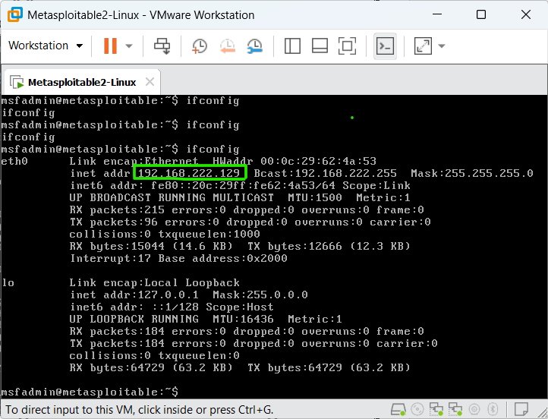
Screenshot 1: Metasploitable 2 IP Address Using ifconfig
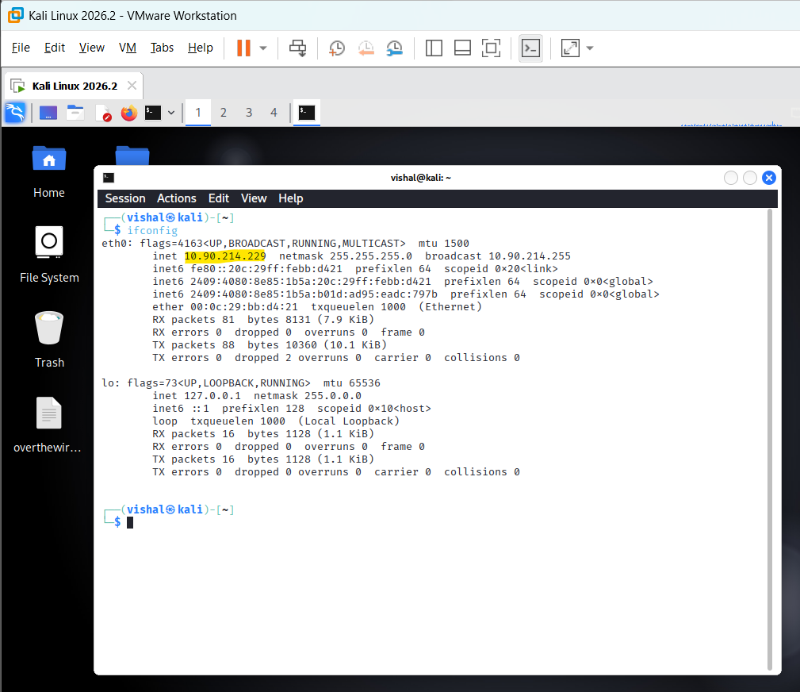
Screenshot 2: Kali Linux terminal showing it's ip address by ifconfig command
Explanation:
The screenshot shows the network configuration of the lab machines. Kali Linux has the IP address 10.90.214.229 (yellow highlight), while Metasploitable 2 has the target IP address 192.168.222.129 (green box). These addresses are used to identify the attacker and target machines during the practical.
Highlight:
- Screenshot 2 the Kali Linux IP address: 10.90.214.229
- Screenshot 1 the Metasploitable 2 IP address: 192.168.222.129
Action:
The identified Metasploitable 2 IP address 192.168.222.129 is used as the target address for subsequent Metasploit testing from Kali Linux.
Step 2: Launch Metasploit Framework
On Kali Linux, open the Terminal and execute: msfconsole
Wait for Metasploit to load. When it finishes, you should see the Metasploit prompt:
msf6 >
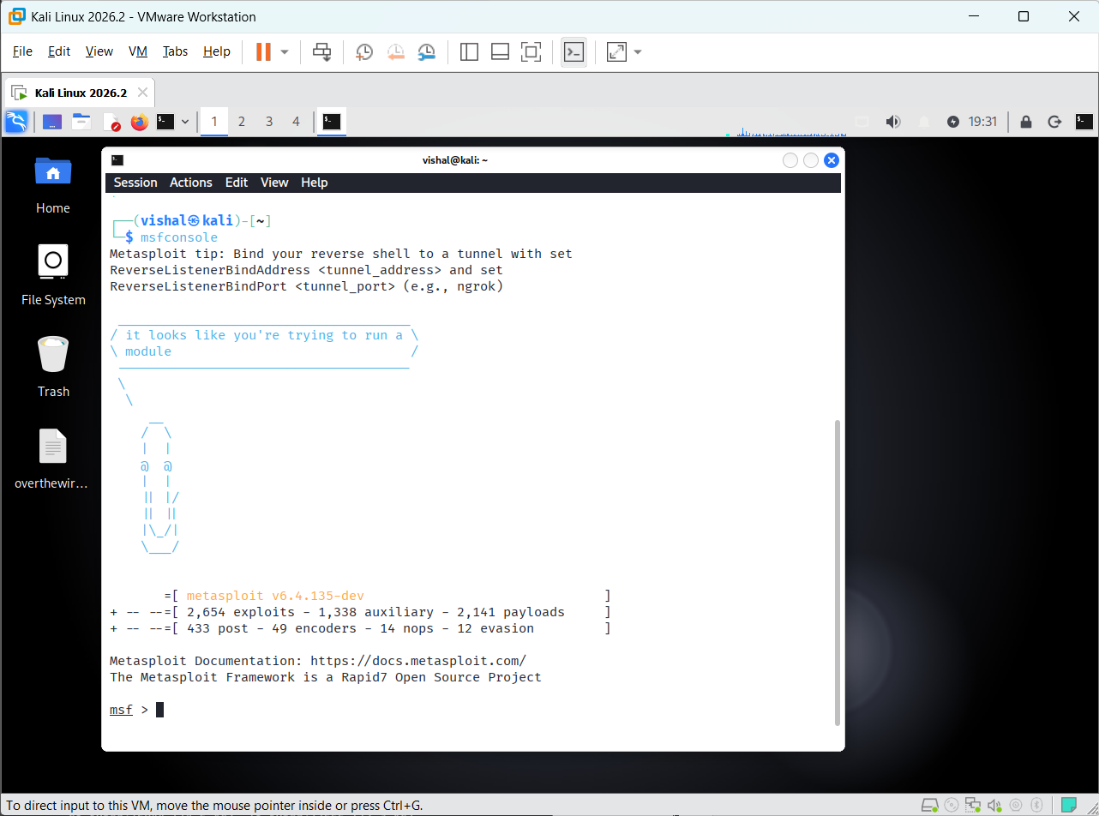
Screenshot 3: Metasploit Framework Console
Explanation:
The screenshot shows the Metasploit Framework successfully launched through msfconsole. The msf6 > prompt indicates that Metasploit is ready to accept commands and perform security testing against the authorized Metasploitable 2 target.
Action:
The Metasploit Framework is initialized and ready for selecting and configuring modules to test the vulnerable services available on Metasploitable 2.

Step 3: Search for FTP Vulnerability
Now that msfconsole is running, we will begin with the FTP service on Metasploitable 2.
At the msf6 > prompt, run: search vsftpd
Metasploitable 2 contains an intentionally vulnerable version of vsFTPd 2.3.4. The search command searches the Metasploit module database for modules related to this vulnerable service.
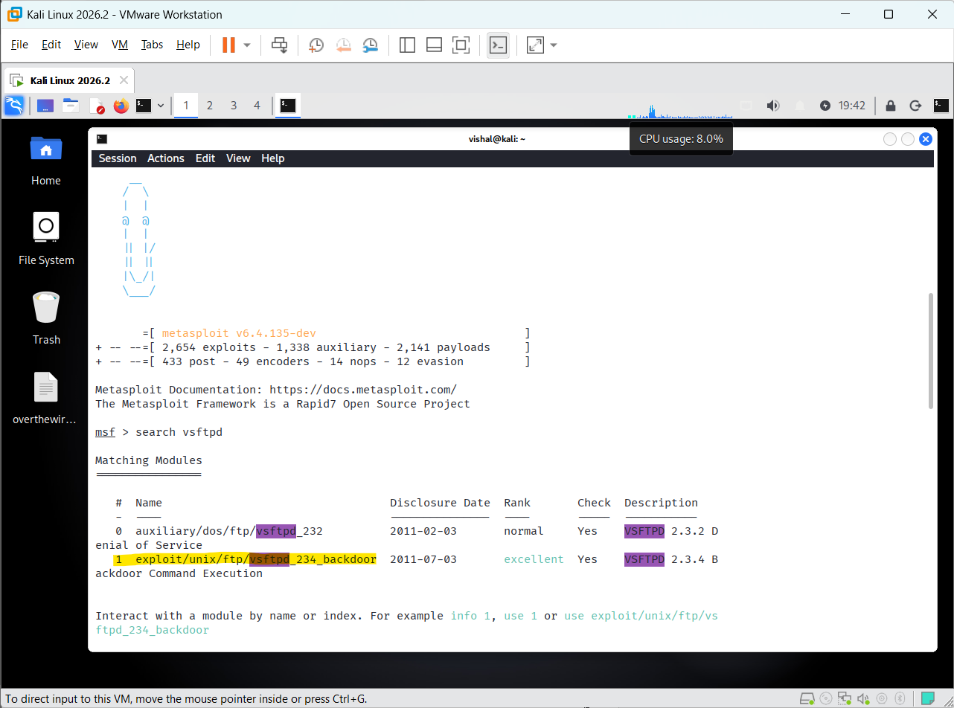
Screenshot 4: Searching for vsFTPd Modules in Metasploit
Explanation:
The screenshot shows the results returned by Metasploit after executing the search vsftpd command. The search identifies available Metasploit modules related to the vsFTPd service, including modules associated with the vulnerable vsFTPd 2.3.4 version.
Action:
The identified vsFTPd-related module is examined to determine its suitability for testing the FTP service running on the Metasploitable 2 target.

Step 4: Select the vsFTPd Backdoor Module
At the msf6 > prompt, execute: use 1
Metasploit will select the module listed at index 1 from the previous search result.
Then run: show options
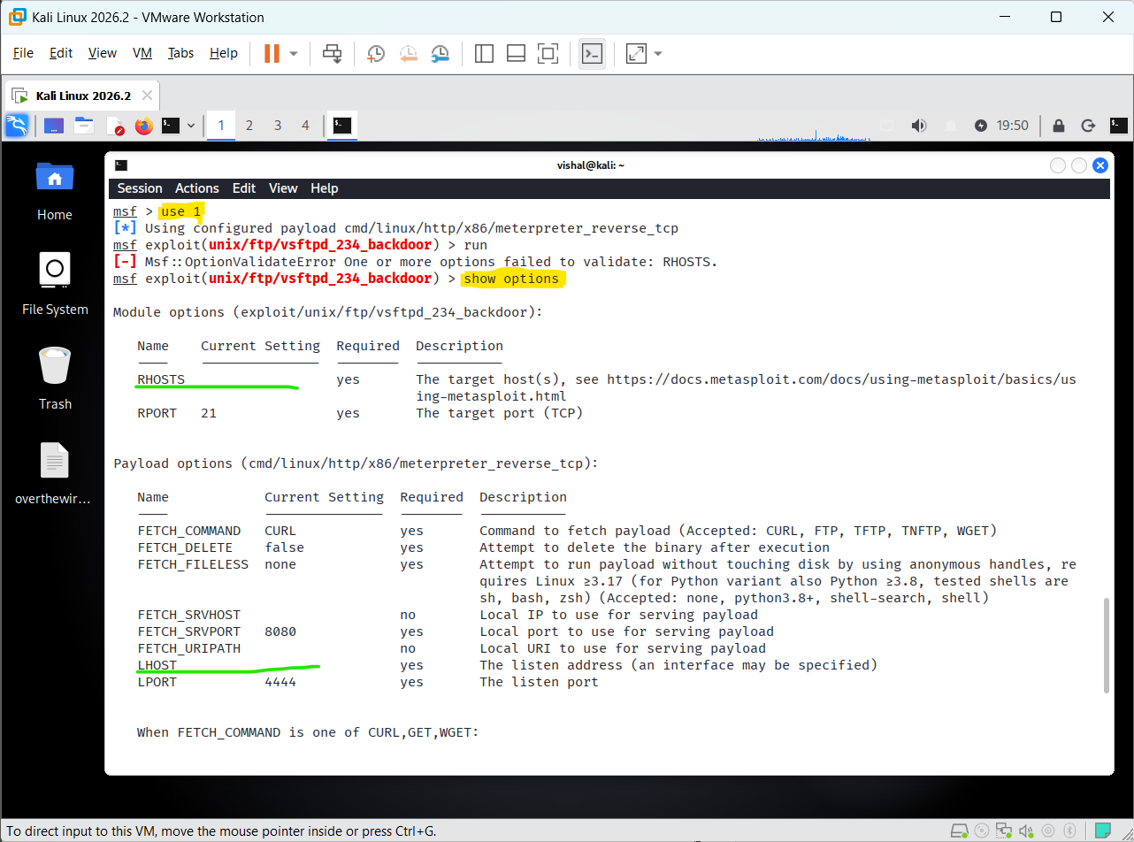
Screenshot 5: vsFTPd Backdoor Module Options
Explanation:
The screenshot displays the configuration options of the selected vsFTPd 2.3.4 backdoor module. It shows the parameters available for configuring the target before executing the security test.
Action:
The module options are reviewed to identify the required target configuration before proceeding with the authorized FTP vulnerability test.

Step 5: Configure RHOSTS and LHOST
5.1 Set the Target IP — RHOSTS
At the current Metasploit prompt, run: set RHOSTS 192.168.222.129
Here:
- RHOSTS = Remote Host(s), meaning the Metasploitable 2 target
- 192.168.222.129 = Metasploitable 2 IP address
You should see: RHOSTS => 192.168.222.129
5.2 Set the Kali IP — LHOST
Now run: set LHOST 10.90.214.229
LHOST = Local Host, meaning the Kali Linux machine
- 10.90.214.229 = Kali Linux IP address
You should see: LHOST => 10.90.214.229
5.3 Verify the Configuration
After setting both values, run: show options
RHOSTS → 192.168.222.129
- LHOST → 10.90.214.229
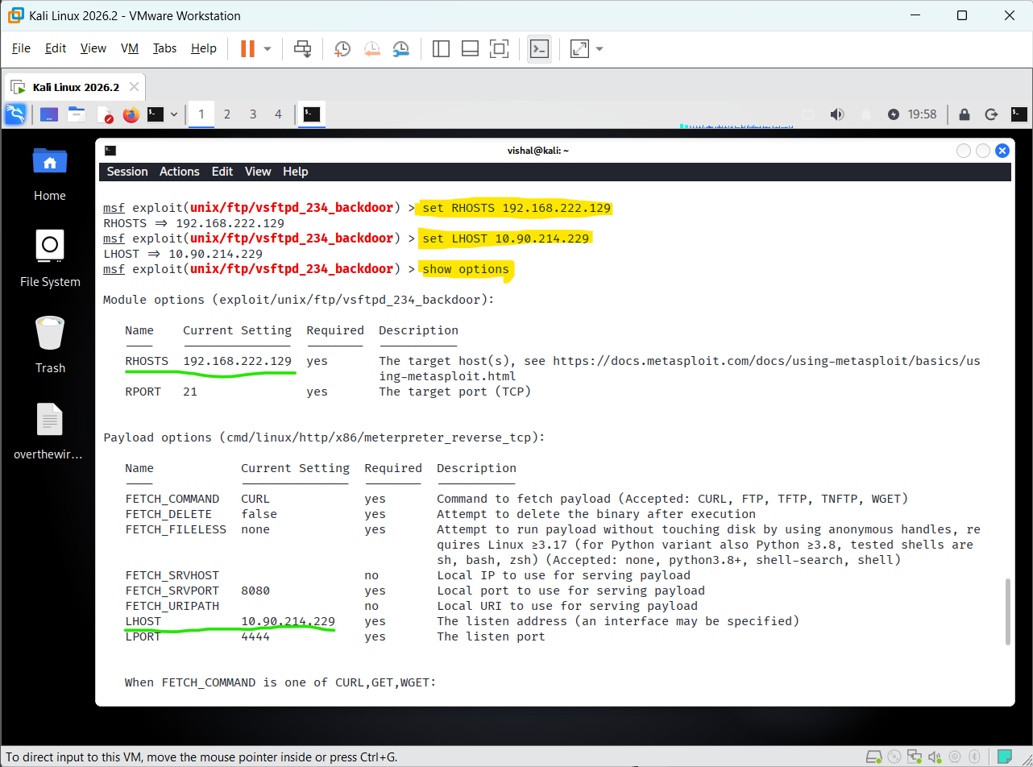
Screenshot 6: Configured RHOSTS and LHOST
Explanation:
The screenshot shows the configuration of the Metasploit module with the IP address of the Metasploitable 2 target specified as RHOSTS and the Kali Linux IP address specified as LHOST. These settings define the target system and the local host used for the subsequent security test.
Action:
The required target and local host parameters are configured, allowing the selected Metasploit module to proceed to the next stage of the FTP vulnerability test.

Step 6: Run the vsFTPd Backdoor Exploit
After configuring the required RHOSTS and LHOST values, execute the selected module using: run
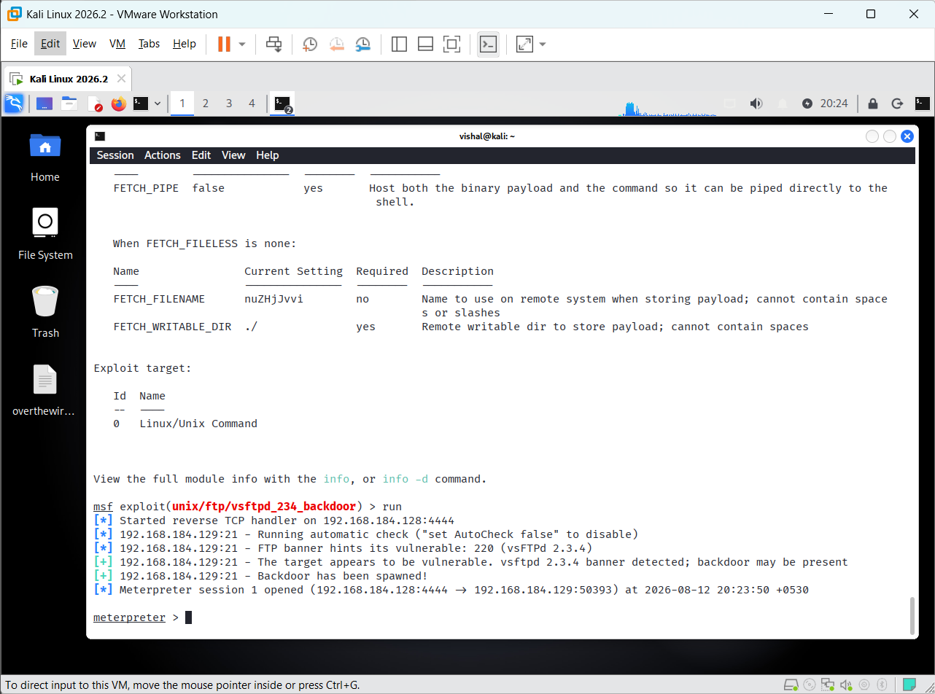
Screenshot 7: Successful vsFTPd 2.3.4 Exploitation
Explanation:
The screenshot shows the successful exploitation of the vulnerable vsFTPd 2.3.4 service on Metasploitable 2. The FTP banner identifies the vulnerable version, and Metasploit reports that the backdoor was successfully spawned. A Meterpreter session is established with the target machine..
A Meterpreter session is successfully established with the Metasploitable 2 target, allowing further authorized security testing to be performed.

Step 7: Identify the SSH Service Version
From the Metasploit console, search for SSH version-related modules: search ssh_version
The search result displays multiple SSH version-related modules. The SSH Version Scanner is selected from the result: use 3
Then display the module configuration: show options
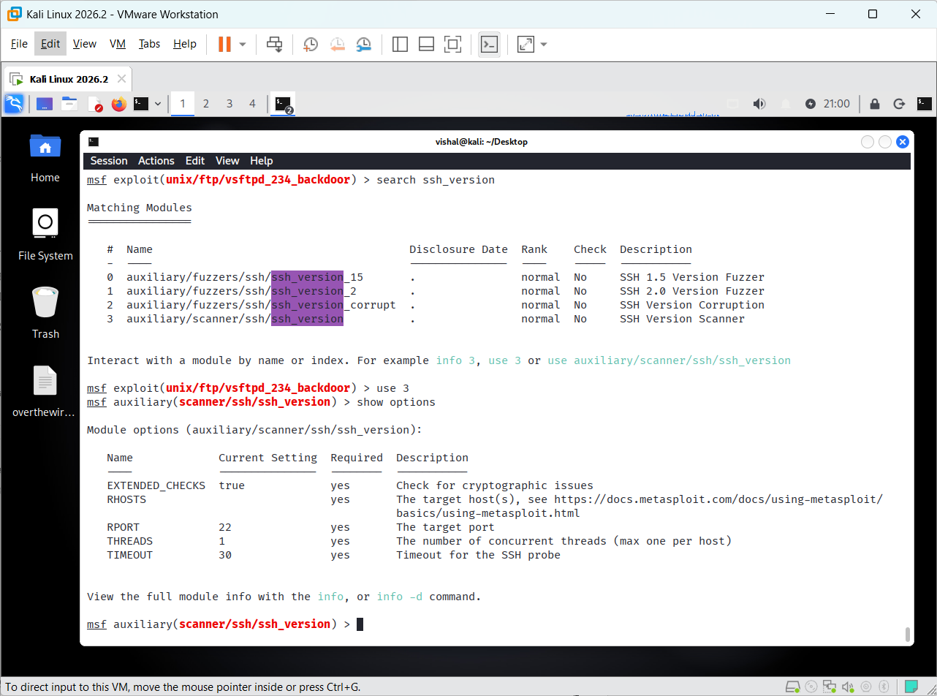
Screenshot 8: SSH Version Scanner Options

Explanation
The screenshot shows the SSH Version Scanner module selected in Metasploit. The show options command displays its configuration, including the required RHOSTS target address and the default SSH port 22. The module is ready to be configured for scanning the SSH service on the target system.
- RHOSTS — required target host.
- RPORT 22 — SSH service port.
- auxiliary/scanner/ssh/ssh_version in the Metasploit prompt to show the selected module.

Step 8: Configure and Scan the SSH Service
Since RHOSTS is required and currently empty, configure it with the Metasploitable 2 target IP: set RHOSTS 192.168.184.129
Then execute the SSH version scanner: run
The scanner will connect to TCP port 22 and identify the SSH service/version running on the target.
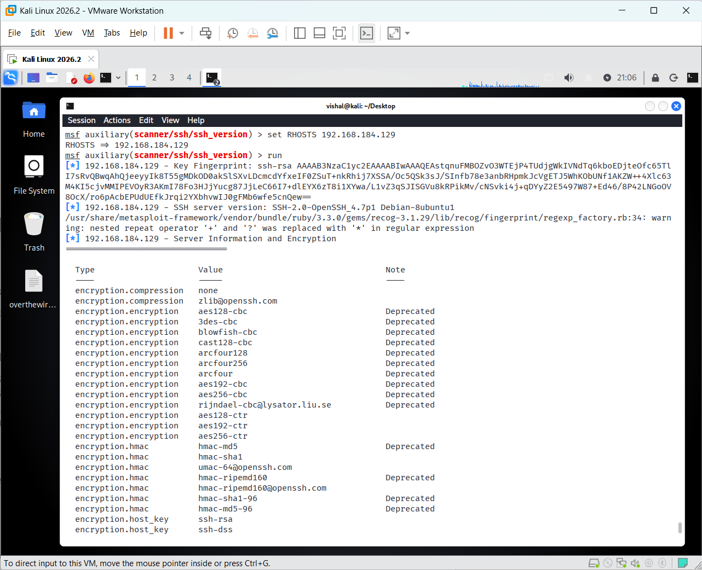
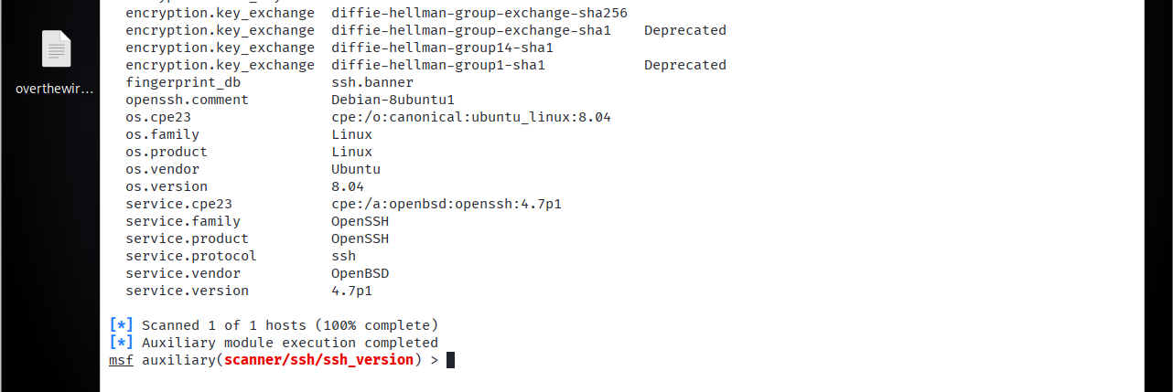
Screenshot 9: SSH Version Scan Result
Explanation:
The screenshot shows the completed SSH version scan and identifies the target's SSH service as OpenSSH 4.7p1 running on Ubuntu Linux 8.04. The scan completed successfully for the target host.
The identified SSH service and version are recorded as the result of the SSH enumeration phase.

Step 10: Select the SSH Login Scanner
The ssh_login module has been selected successfully, and show options displays the parameters available for testing SSH authentication.
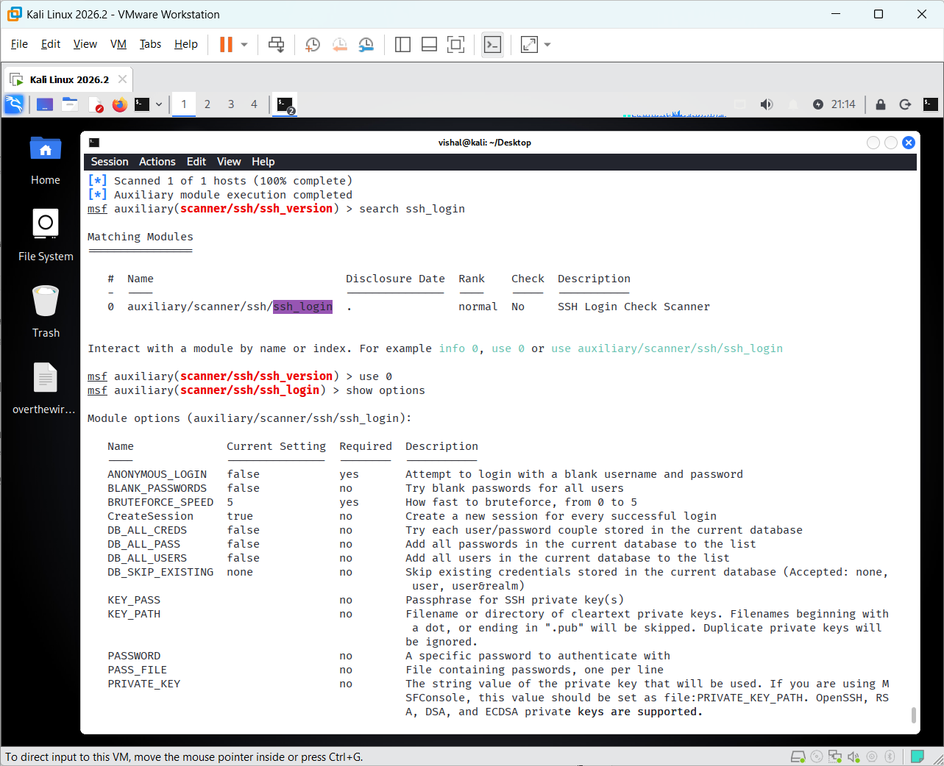
Screenshot 10: SSH Login Scanner Options
Explanation:
The screenshot shows the SSH Login Check Scanner module selected in Metasploit. The show options command displays the available authentication and target configuration parameters. The default SSH port is 22, while RHOSTS, USERNAME, and PASSWORD are available for configuring the authorized Metasploitable 2 login test.
The SSH login scanner is configured to test authentication against the authorized Metasploitable 2 SSH service using its default laboratory credentials.

Step 11: Verify Successful SSH Authentication
The SSH Login Scanner successfully authenticated to the Metasploitable 2 SSH service using the configured laboratory credentials and opened SSH session 1.
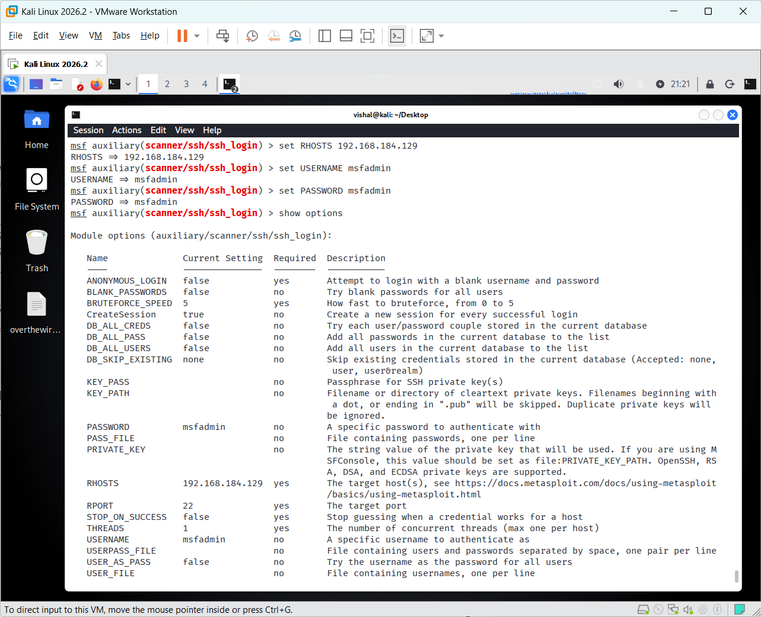
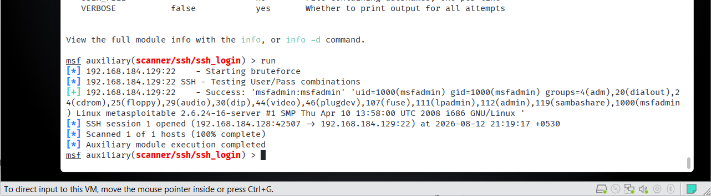
Screenshot 11: Successful SSH Login and Session
Explanation:
The screenshot shows the successful SSH authentication result. Metasploit reports the valid msfadmin credentials and confirms that SSH session 1 was opened. The output also displays system information identifying the target as the Metasploitable Linux system.
The successful SSH authentication and session establishment are recorded as evidence of successful SSH access to the authorized Metasploitable 2 laboratory system.

Step 12: Select the MySQL Version Scanner
From the Metasploit console, search for the MySQL version scanner: search mysql_version
The mysql_version module is identified and selected using: use 0
Then display its configuration: show options
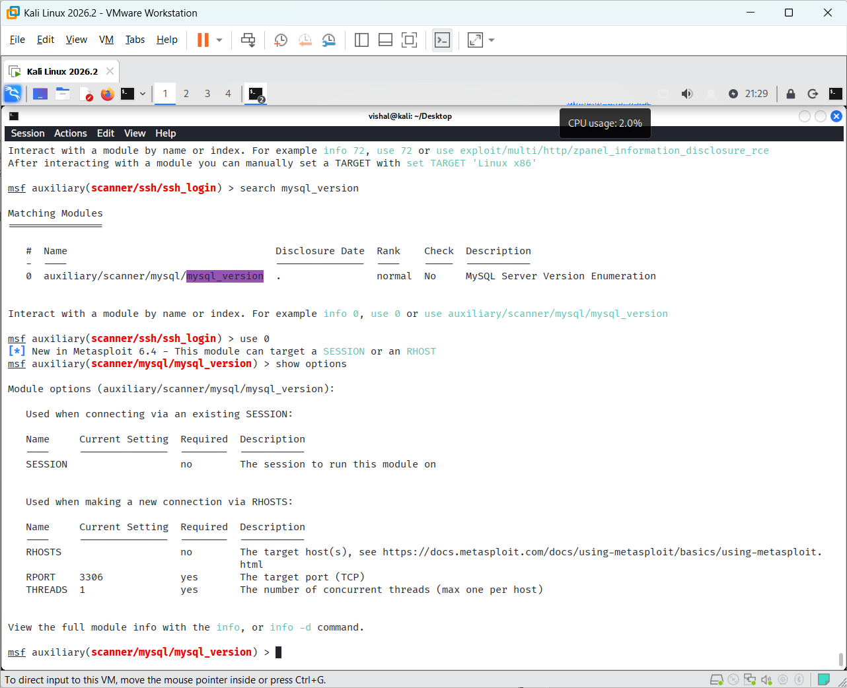
Screenshot 12: MySQL Version Scanner Options
Explanation:
The screenshot shows the MySQL Server Version Enumeration module selected in Metasploit. The show options command displays the available connection parameters. The module can connect using an existing session or directly to a target through RHOSTS; for a direct connection, the default MySQL port is 3306.
The MySQL Version Scanner configuration is reviewed before connecting to the MySQL service on the authorized Metasploitable 2 target.

Step 13: Access MySQL Database
From the Metasploit console, connect to the MySQL service using the available root account: mysql -h 192.168.184.129 -u root --skip-ssl
After successfully connecting, display the available databases: show databases;
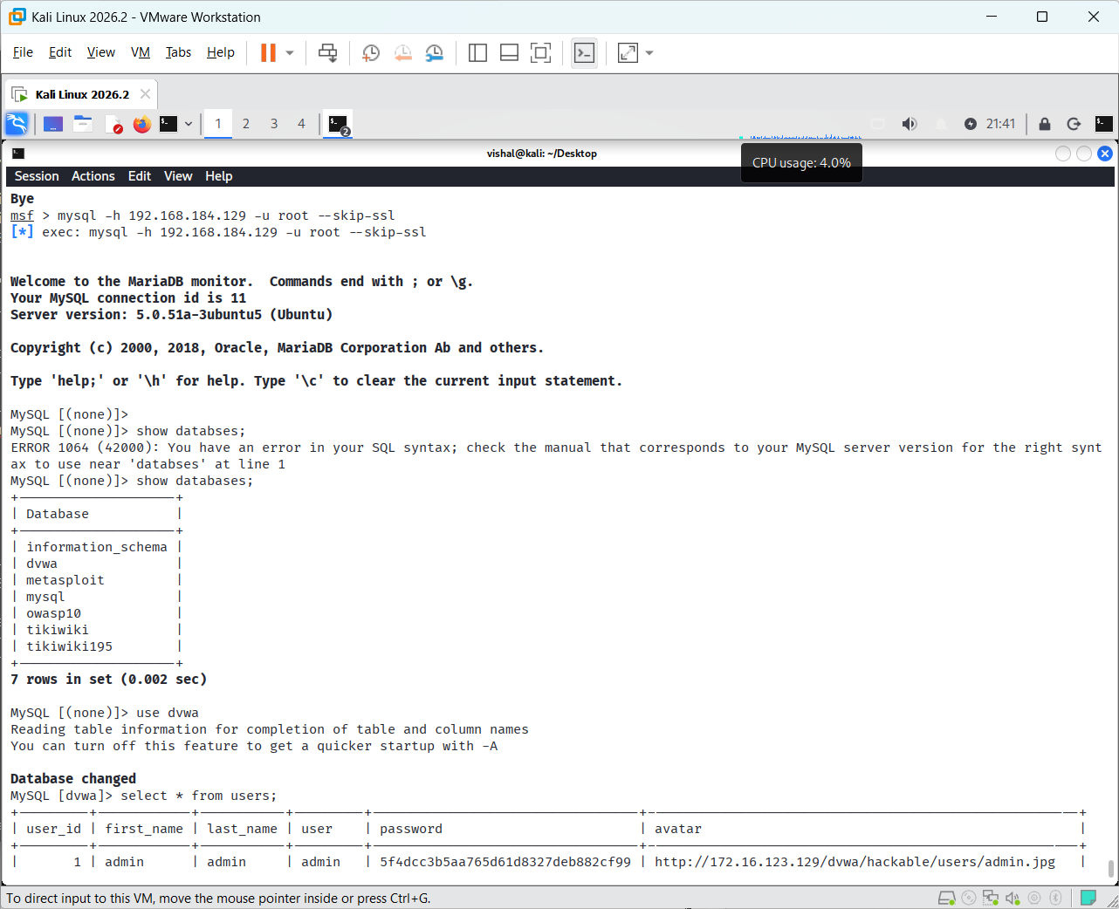
Screenshot 13: MySQL Database and User Records
Then select the dvwa database: use dvwa;
Finally, display the records from the users table: select * from users;
Explanation:
The screenshot shows a successful connection to the MySQL server and the available databases. The dvwa database is selected, and the users table is queried to display its stored records.
The successful MySQL connection, database enumeration, and retrieval of records from the dvwa database are recorded as evidence of database access in the authorized Metasploitable 2 environment.

Conclusion:
The practical successfully demonstrated the use of Metasploit (msfconsole) for security testing of FTP, SSH, and MySQL services on the authorized Metasploitable 2 environment. The vulnerable FTP service was exploited, SSH authentication was successfully tested, and MySQL databases and user records were accessed. This practical provided hands-on understanding of service enumeration, authentication testing, and exploitation in a controlled laboratory environment.

Practical-2
AIM: “To perform a controlled brute-force attack on an FTP service using Hydra and identify valid login credentials.”

Step 1: Prepare Username and Password Lists
On Kali Linux, create the working directory and move to the Desktop: cd Desktop
Create a username list: nano user.txt
Add multiple usernames, including the valid Metasploitable 2 username.
Create a password list: nano pass.txt
Add multiple passwords, including the valid password.
The lists are then used by Hydra to test combinations against the authorized FTP service.
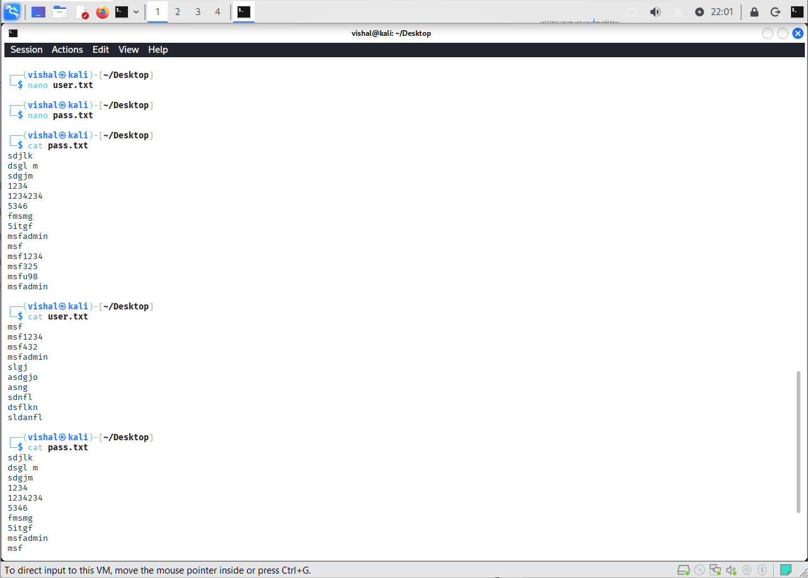
Screenshot 1: Username and Password Lists
Explanation:
The screenshot shows the prepared username and password lists used for the authorized brute-force testing activity.
The username and password lists are prepared for use with Hydra.

Step 2: Perform FTP Brute-Force Attack Using Hydra
The prepared username and password lists are supplied to Hydra using the -L and -P options:
hydra -L user.txt -P pass.txt ftp://192.168.184.129
Here, -L specifies the username list, -P specifies the password list, and ftp://192.168.184.129 specifies the authorized FTP target.
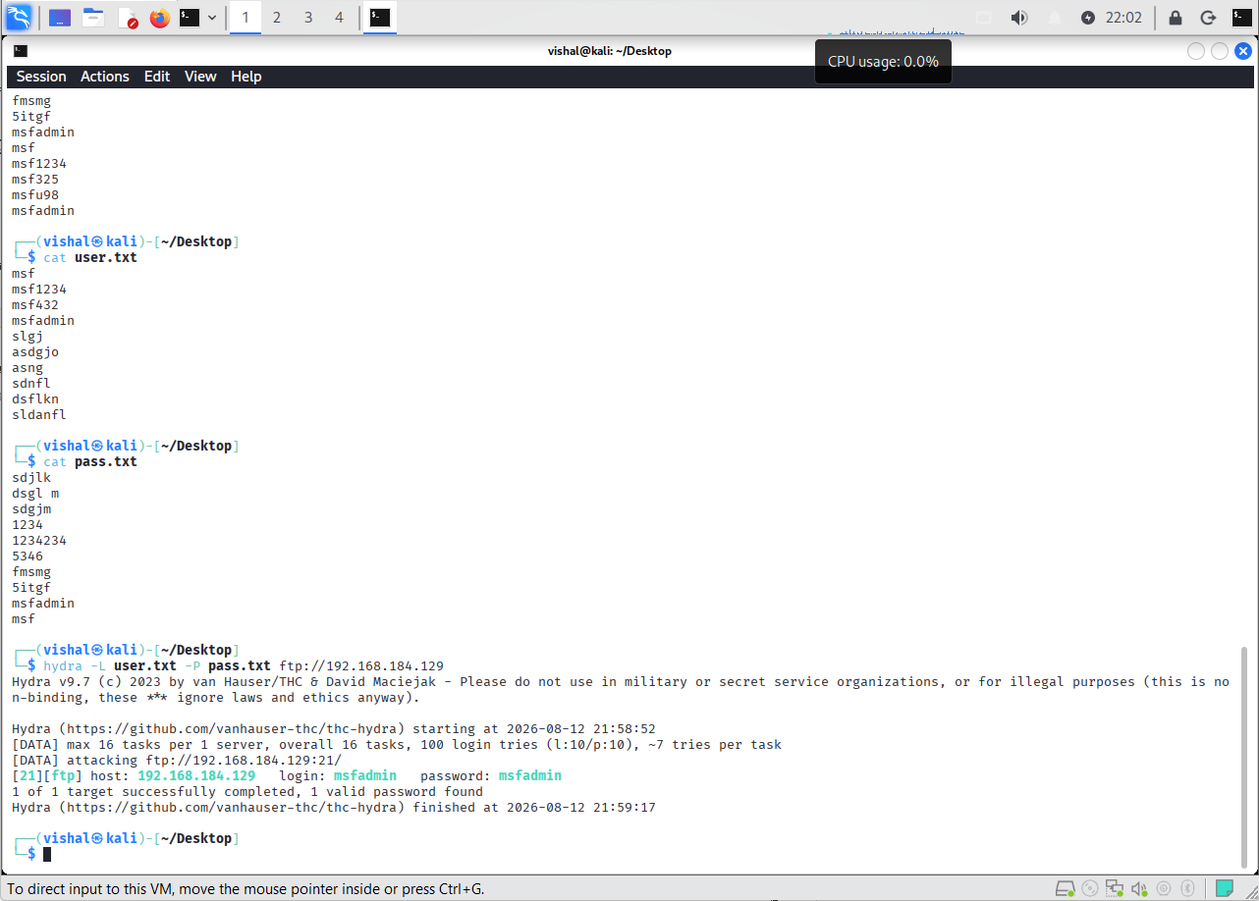
Screenshot 2: Successful FTP Brute-Force Result Using Hydra
Explanation:
The screenshot shows Hydra testing the supplied username and password combinations against the FTP service on the authorized Metasploitable 2 system. Hydra successfully identifies the valid credentials msfadmin:msfadmin and reports that one valid password was found.
The valid FTP credentials identified by Hydra are recorded as the result of the authorized brute-force testing.
Observation
Username and password wordlists were created in Kali Linux using user.txt and pass.txt. Hydra was used to test username and password combinations against the authorized FTP service on the Metasploitable 2 target. The scan completed successfully, and Hydra reported one valid password found. The output identified the username as msfadmin for the target FTP service at 192.168.184.129. The practical demonstrated how weak or predictable credentials can be discovered through dictionary-based brute-force testing.

Conclusion
The FTP brute-force practical was successfully completed using Hydra and custom username and password wordlists. The tool identified valid FTP credentials on the intentionally vulnerable Metasploitable 2 system. This demonstrates the security risks associated with weak passwords and highlights the importance of using strong, unique credentials, limiting repeated login attempts, and monitoring authentication logs.

Practical-3
AIM: “To understand how a simulated phishing login page can capture login information in a controlled local environment using Zphisher.”

Tools Required
- Kali Linux
- Zphisher
- Web browser
- Local web server
Step 1: Installation and Setup of Zphisher
- Open the Kali Linux terminal.
- Navigate to the Desktop directory using cd ~/Desktop.
- Clone the Zphisher repository using the command below:
git -c http.version=HTTP/1.1 clone --depth 1 https://github.com/htr-tech/zphisher.git
- Enter the downloaded directory using cd zphisher.
- Read the README file to review the installation requirements.
- Follow the repository's documented setup instructions.
- Start the script using ./zphisher.sh after completing the setup.
Step 2: Launch Zphisher and Select the Simulation
- Run ./zphisher.sh from the Zphisher directory.
- The main menu displays different simulated login-page options.
- Select the Google option from the menu.
- Select the new Google login-page option from the next menu.
- Choose the Localhost hosting option.
- Follow the prompts displayed by the tool to start the local simulation.
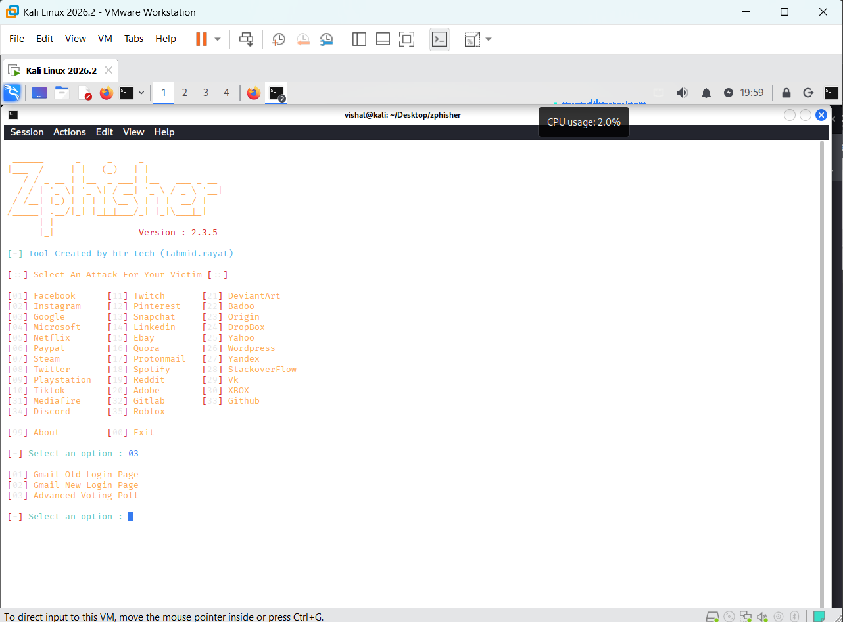
Figure 1: Zphisher Main Menu and Simulation Selection
POC Explanation: The screenshot shows Zphisher running successfully and displaying the available simulation options. The Google option has been selected, and the tool presents different login-page choices. This provides evidence that the tool has started and the simulation can be configured.
Step 3: Configure Local Hosting
- After selecting the login-page option, Zphisher displays the available hosting methods.
- Select Localhost for the local demonstration.
- Follow the prompt about using a custom port.
- Enter the appropriate response to continue with the default or configured port.
- Wait for the tool to display the local server address.
- Open that address in the browser running inside the same lab environment.
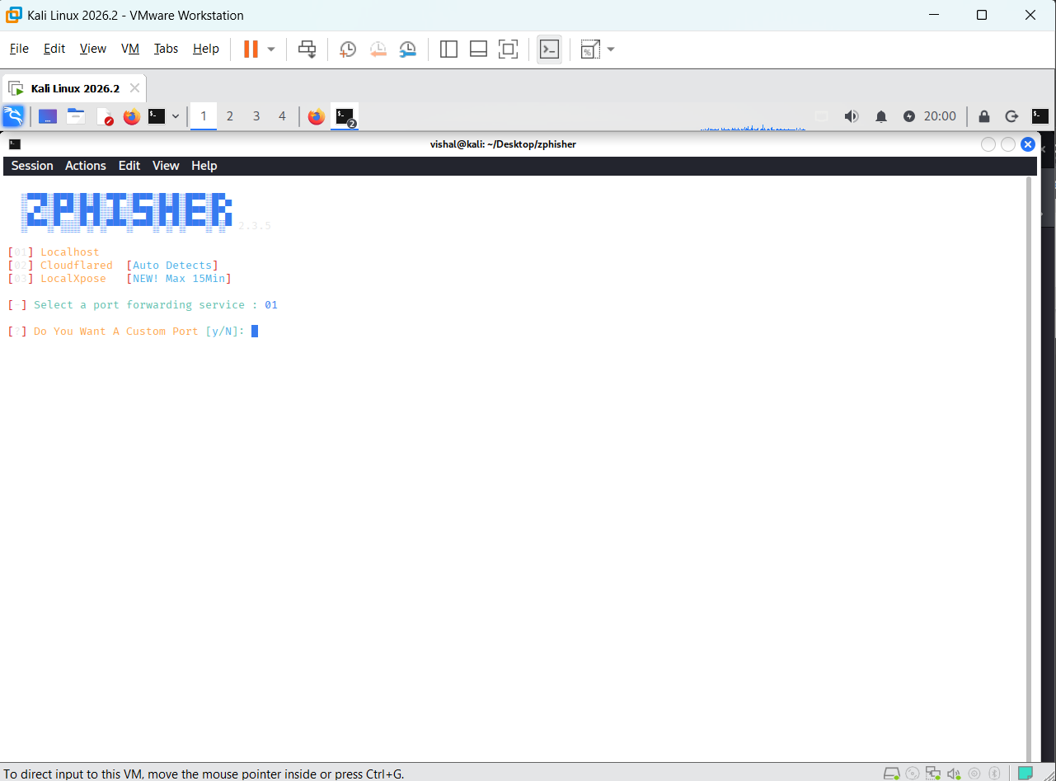
Figure 2: Localhost Hosting Configuration
POC Explanation: The screenshot shows the hosting-method selection and the prompt for configuring a port. It demonstrates that the local hosting configuration is being performed. The screenshot alone does not prove that the login page has successfully loaded; that must be confirmed in the browser.
Step 4: Observe the Simulation Results
- After submitting fictional test information in the local demonstration, return to the Zphisher terminal.
- Observe the messages displayed by the tool.
- The terminal screenshot shows that the tool reports a login-information event.
- It displays the submitted account field and password field.
- The displayed IP address is 127.0.0.1, which is the loopback address of the local machine.
- Record the result and stop the simulation using Ctrl + C.
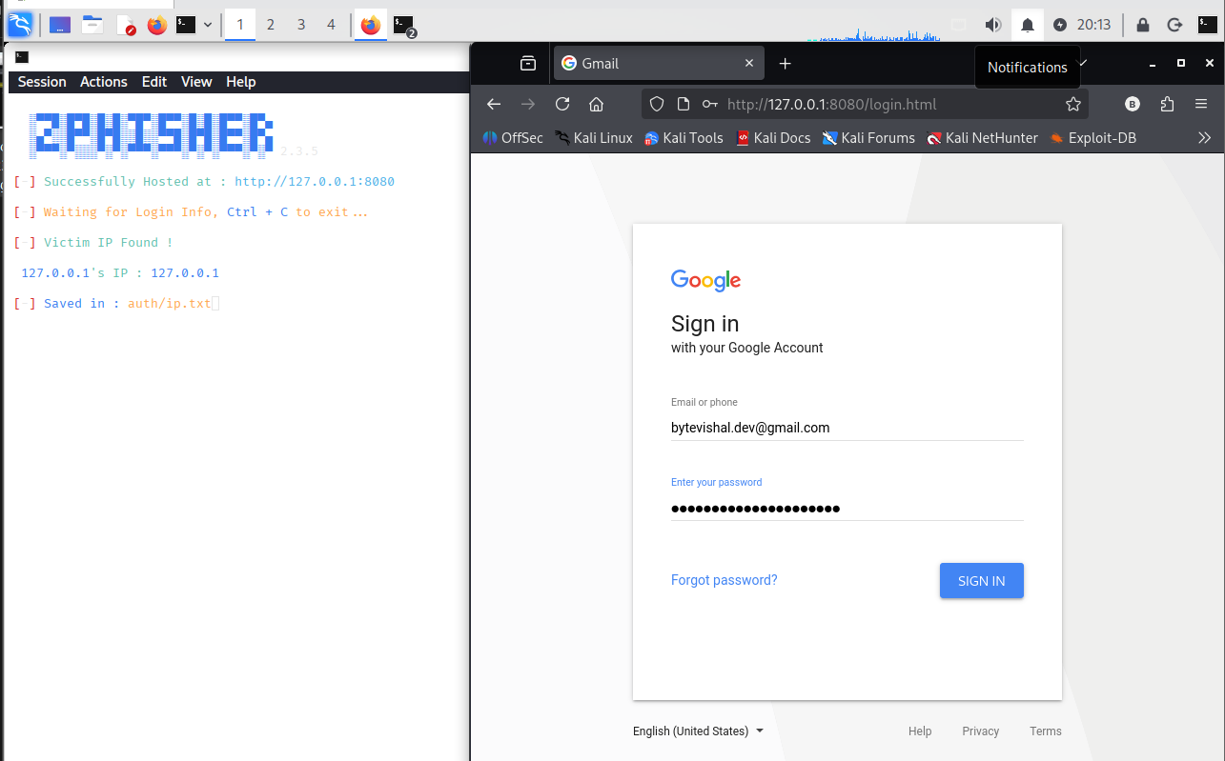
Figure 3: open 127.0.0.1:8080 page and enter email and password
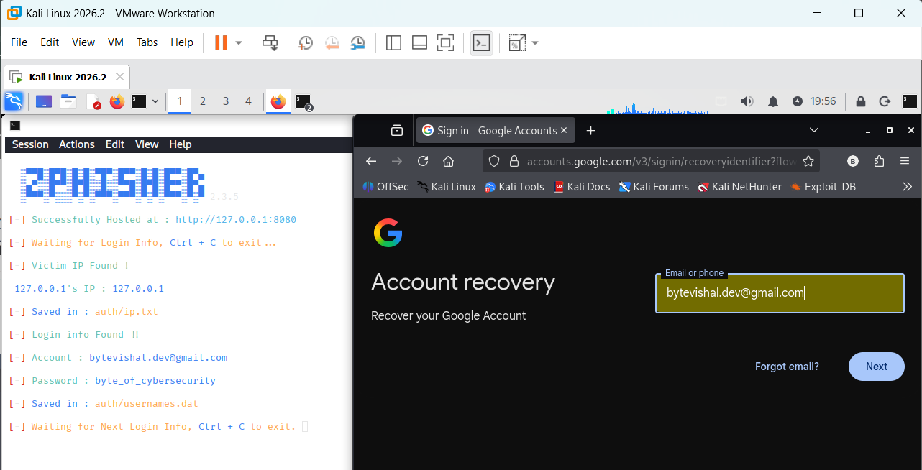
Figure 4: Zphisher Terminal Showing the Simulation Results
POC Explanation: The screenshot provides evidence that the tool displayed submitted test values in the terminal. This demonstrates how a simulated phishing page can collect information entered into its fields. The 127.0.0.1 address indicates a local loopback connection rather than identifying a remote victim.
Observation
Zphisher was launched in Kali Linux, and a simulated Google-style login page was configured for local hosting. The terminal displayed the submitted test values, demonstrating how a phishing-style page can collect information entered by a user.
Conclusion
The practical demonstrated the basic operation of Zphisher in a controlled local environment. It helped explain how simulated phishing pages can collect submitted information and why users should verify website authenticity before entering credentials.

Practical-4
AIM: “To perform a controlled brute-force attack on the DVWA login page using Burp Suite Intruder and identify valid login credentials”

Tools Required
- Kali Linux
- DVWA (Damn Vulnerable Web Application)
- Burp Suite
- Firefox browser
Procedure
Step 1: Open DVWA and Configure Burp Suite
- Started the Kali Linux virtual machine and opened Firefox.
- Opened the DVWA web application running on the Metasploitable virtual machine.
- Logged in to DVWA and navigated to the Brute Force page.
- Set the DVWA security level to Low for the controlled lab exercise.
- Opened Burp Suite and selected the Proxy tab.
- Configured Firefox to use Burp Suite's proxy at 127.0.0.1:8080.
- Enabled request interception and confirmed that browser traffic could be captured.
- Prepared the environment for testing login requests within the authorized lab.
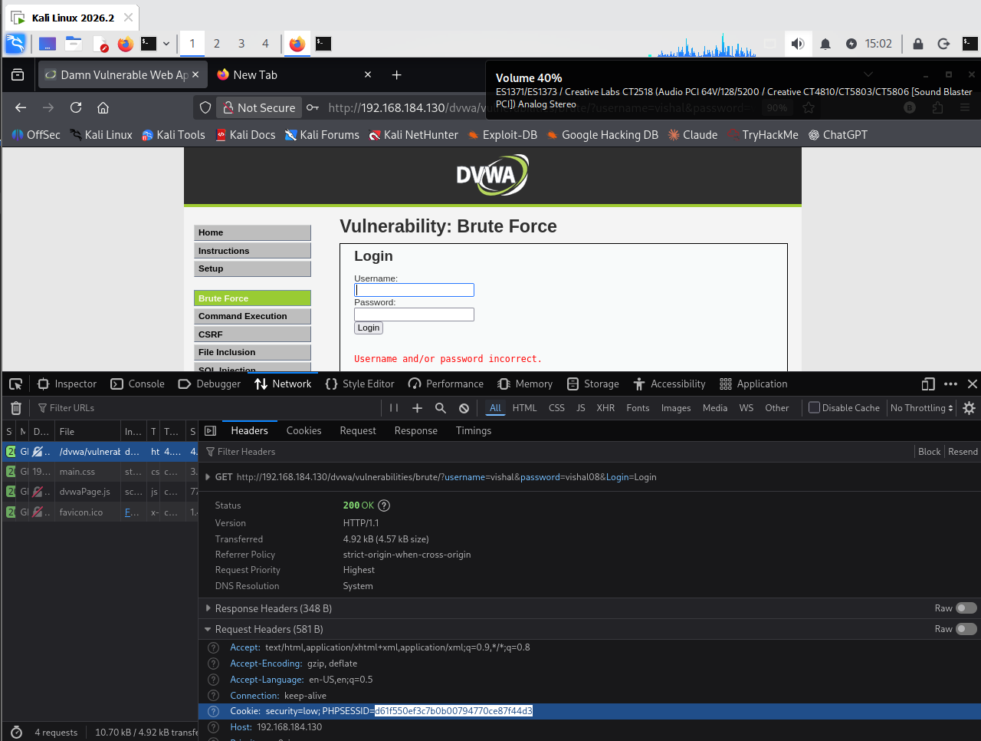
Figure 4: DVWA Brute Force page and browser DevTools showing the captured request, cookie, and the real "Username and/or password incorrect." failure text.

Step 2: Intercept and Analyze the Login Request
- Opened the DVWA Brute Force page in Firefox.
- Entered a test username and an incorrect password in the login form.
- Clicked the Login button to generate an HTTP request.
- Observed that Burp Suite intercepted the request through its Proxy tab.
- Examined the request method, URL, headers, cookies, and form parameters.
- Identified the parameters carrying the username and password values.
- Checked the response message displayed by DVWA after the unsuccessful login attempt.
- Sent the captured request to the Intruder tool for controlled testing.
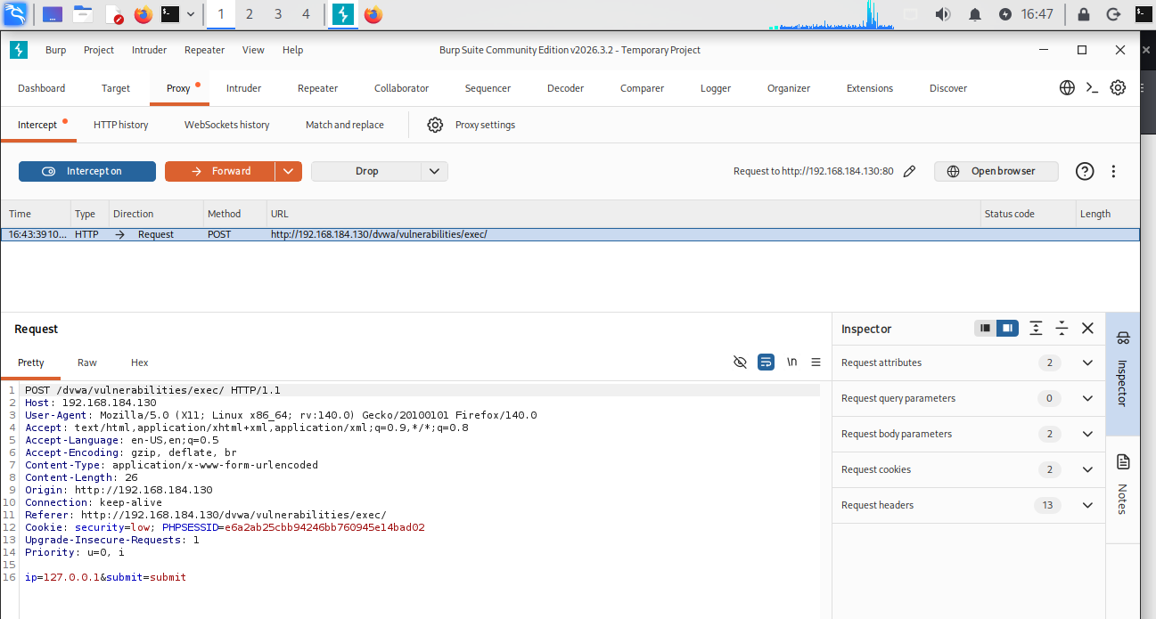
Figure 2: Intercepting HTTP Request Using Burp Proxy
Step 3: Configure Burp Suite Intruder
- Opened the Intruder tab in Burp Suite.
- Selected the intercepted DVWA login request.
- Opened the Positions section to configure the values to be tested.
- Marked the appropriate username and password parameters as payload positions.
- Removed any unnecessary automatically selected positions.
- Selected a suitable attack type for the controlled login test.
- Opened the Payloads section and prepared small, predefined test lists.
- Used only test values appropriate for the authorized lab account.
- Reviewed the configuration before starting the test.

Step 4: Execute the Test and Analyze Responses
- Started the configured Intruder attack against the DVWA lab application.
- Allowed Burp Suite to submit the selected test values.
- Observed the response status codes and response lengths in the results table.
- Compared the responses with the message received during an unsuccessful login attempt.
- Looked for differences that could indicate a potentially successful authentication attempt.
- Examined unusual responses carefully instead of treating every difference as a valid password.
- Identified any candidate credentials that required further verification.
- Kept the test limited to the intended lab system and the predefined test values.
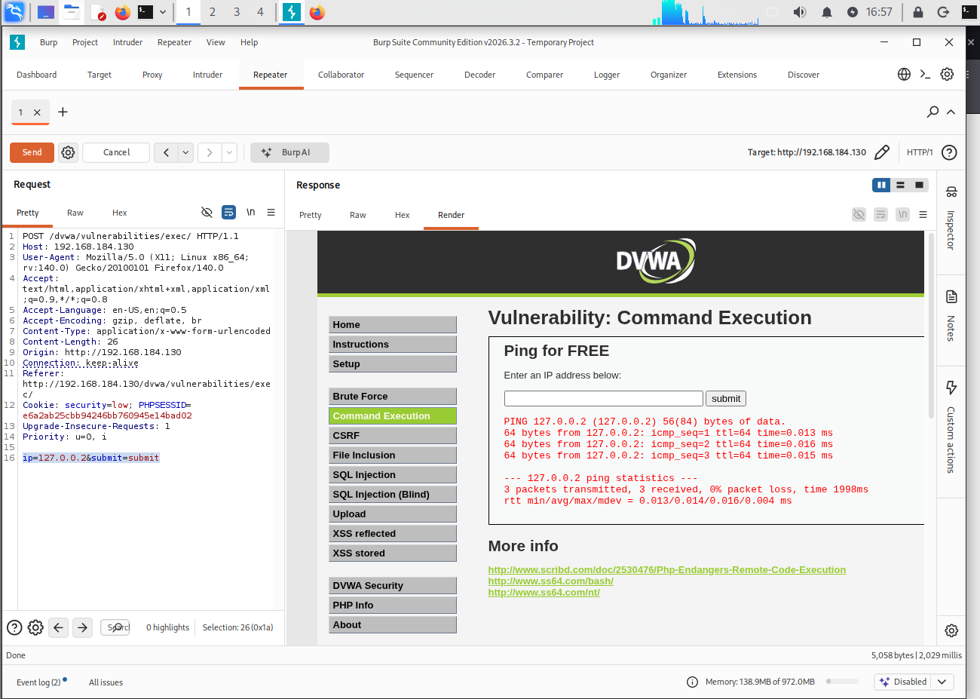
Figure 3: Modifying and Resending Request Using Repeater

Step 5: Verify the Findings and Complete the Test
- Reviewed the Intruder results and selected any potentially valid credential pair for verification.
- Opened the DVWA login page in Firefox and tested the candidate credentials manually.
- Checked whether DVWA successfully authenticated the test account.
- Recorded the verified result and the relevant response observations.
- If no credentials were confirmed, recorded that the test did not identify a valid pair.
- Stopped the test after completing the planned attempts.
- Summarized the security weakness and considered suitable preventive measures.
Observation
Burp Suite Intruder automated a limited set of login attempts against the DVWA Brute Force page. The responses could be compared using status codes, response lengths, and application messages. Differences helped identify requests that required further investigation. A successful login had to be verified separately before the credentials could be reported as valid.
Input | Result
1 | Displayed only the admin record
1' OR '1'='1' # | Displayed five user records

Conclusion
The practical demonstrated how to intercept a DVWA login request using Burp Suite Proxy and configure Intruder for controlled authentication testing. Comparing server responses helped identify potentially valid credentials for further verification. The exercise illustrated how unrestricted login attempts can expose weak passwords and why rate limiting, multi-factor authentication, and security monitoring are important preventive controls.
Practical-5
AIM: “To use theHarvester to perform passive information gathering and collect publicly available information about a target domain”

Passive reconnaissance collects information from public sources and DNS without trying to exploit or gain access to the target. This exercise was performed on vulnweb.com, a public test domain intended for security-tool practice, from a Kali Linux virtual machine in VMware Workstation. The lab commands were run on 10 October 2026. The VM used the NAT resolver at 192.168.222.2 for DNS queries. The certificate sources used by theHarvester receive the domain name as a query.

Procedure
- The terminal was opened in the Kali Linux VM, and a working folder was created (mkdir ~/q7 && cd ~/q7).
- theHarvester 4.10.1 was run with the passive certificate sources crtsh and certspotter. Its output was saved as q7_recon (XML and JSON).
- WHOIS, nslookup and dig were run one at a time, and the output was saved as screenshots.
- The DNS results from nslookup and dig were compared.

Commands used
theHarvester -d vulnweb.com -b crtsh,certspotter -f q7_recon
whois vulnweb.com
nslookup vulnweb.com
nslookup -type=MX vulnweb.com
dig vulnweb.com A
dig vulnweb.com MX
dig vulnweb.com NS
dig vulnweb.com TXT
theHarvester queries the selected public certificate sources and collects any domains, subdomains, IP addresses and e-mail addresses they return. WHOIS shows registration data such as the registrar, dates, status and name servers. nslookup and dig query DNS. A and AAAA records give IPv4 and IPv6 addresses, MX records name the mail servers, NS records name the authoritative name servers, and TXT records hold text such as domain-verification and e-mail policy data.

Results to record
Information requested | Your observed result | Source / command
Domain | vulnweb.com | All commands
Subdomains / hostnames | No result returned. theHarvester reported no hosts, IPs, e-mails or people from crtsh and certspotter. | theHarvester
IP addresses (A / AAAA) | A: 44.228.249.3.  AAAA: 64:ff9b::2ce4:f903 | nslookup;  dig A
DNS records (NS / TXT / other) | NS: ns-136.awsdns-17.com, ns-557.awsdns-05.net, ns-1450.awsdns-53.org, ns-1588.awsdns-06.co.uk. TXT: a Google site-verification record and an SPF record (v=spf1 ~all). | dig NS; dig TXT
Mail servers (MX) | Registrar: Gandi SAS (IANA ID 81). Created: 2010-06-14. Updated: 2026-06-01. Expires: 2027-06-14. Status: clientTransferProhibited. DNSSEC: unsigned. Name servers: the same four as in the NS row. | nslookup -type=MX; dig MX
WHOIS details (as publicly available) | Complete after the authorized run | whois

Screenshot evidence
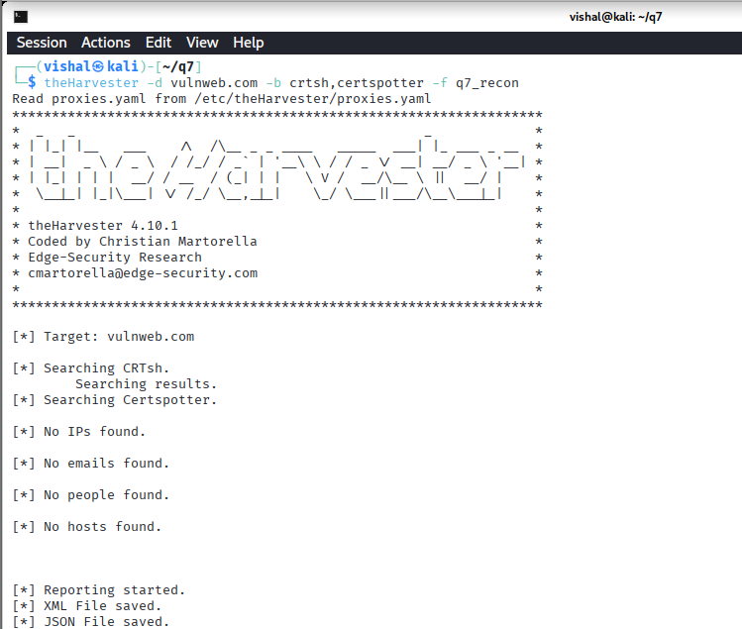
Figure 3: theHarvester passive reconnaissance output for vulnweb.com using crtsh and certspotter.
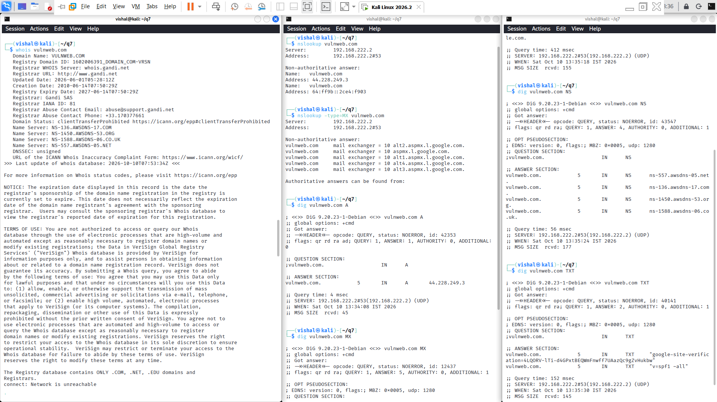
Figure 4: WHOIS, nslookup and dig output for vulnweb.com.

Conclusion
Passive reconnaissance of vulnweb.com showed its A and AAAA records, its four name servers, five Google mail servers, its TXT records and its registration details. It did not need any direct interaction with the target's own services. The exercise also shows why DNS and WHOIS data should be reviewed by defenders. Details such as mail providers, DNS hosting and e-mail policy are public and can help an attacker, so organizations should review what they expose.

Practical-6
AIM: “Brute-Force Attack on DVWA Using Burp Suite Intruder”

Procedure
Step 1: Open DVWA and Set the Security Level
- Start Kali Linux and open Mozilla Firefox.
- Access the DVWA application hosted on the lab machine.
- Log in to DVWA using the lab account.
- Select Brute Force from the left-side menu.
- Open DVWA Security and set the security level to Low.
- Return to the Brute Force page and observe the username and password fields.
- Enter a test username and an incorrect password.
- Submit the form and observe the unsuccessful login message.
Figure 1: DVWA Brute Force page displaying the login form and an unsuccessful login message.

Step 2: Observe the Login Request
- Open Firefox Developer Tools and select the Network tab.
- Submit the DVWA login form using test credentials.
- Select the request associated with the login attempt.
- Examine the request URL, method, parameters, and cookies.
- Identify the username and password parameter names.
- Observe the server response and note the message displayed for a failed login.
- Use this information to understand how the login request is transmitted to the web application.
- Record the request details required for the authorized lab test.

Step 3: Configure Burp Suite Proxy
- Open Burp Suite Community Edition.
- Configure Firefox to send its traffic through Burp Suite's proxy.
- Open the Proxy tab and enable interception.
- Return to the DVWA Brute Force page and submit another test login.
- Observe the intercepted HTTP request in Burp Suite.
- Inspect the request method, path, headers, cookies, and form parameters.
- Confirm that the request belongs to the Brute Force page before using it.
- Forward the request or send it to Intruder for further testing.
Figure 3: Capture a new screenshot showing the actual DVWA Brute Force request.

Step 4: Configure and Run Burp Suite Intruder
- Open the actual DVWA Brute Force request in Burp Suite Intruder.
- Review the request parameters and identify the fields intended for testing.
- Configure the positions for the authorized test inputs.
- Select a suitable Intruder attack type for the controlled lab exercise.
- Add a small, predefined set of test values to the payload configuration.
- Review the target and payload settings before starting the test.
- Start the attack and observe the responses returned by DVWA.
- Compare response status, length, and message differences between attempts.
- Do not assume that a different response automatically means a valid password.
- Record the results and stop the test after completing the authorized checks.
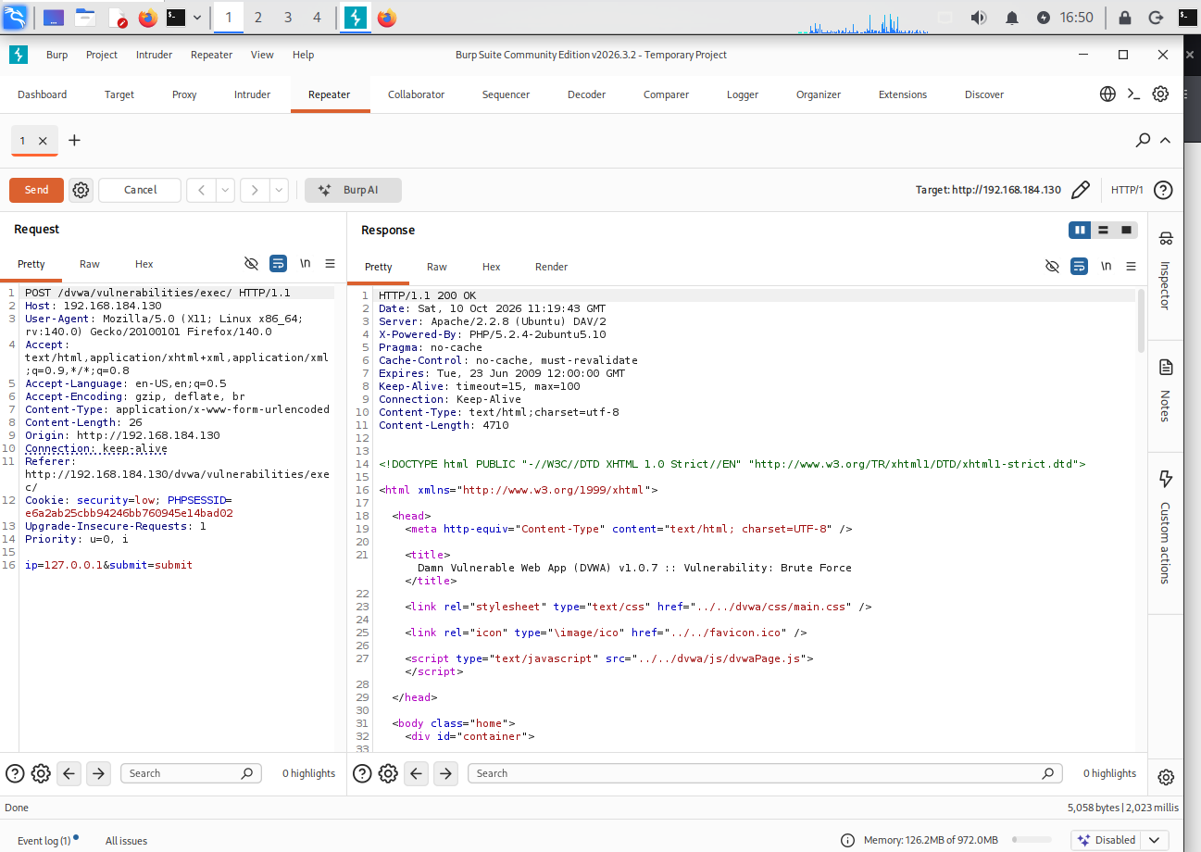

Step 5: Verify and Record the Results
- Review the Intruder results and identify any responses that differ from the normal failed-login response.
- Treat unusual responses only as candidates for further verification.
- If a candidate credential is identified, verify it manually within the authorized DVWA lab.
- Record whether a successful login was confirmed.
- If no successful login is confirmed, report that the test did not establish valid credentials.
- Stop the test and restore the application to its normal lab state.
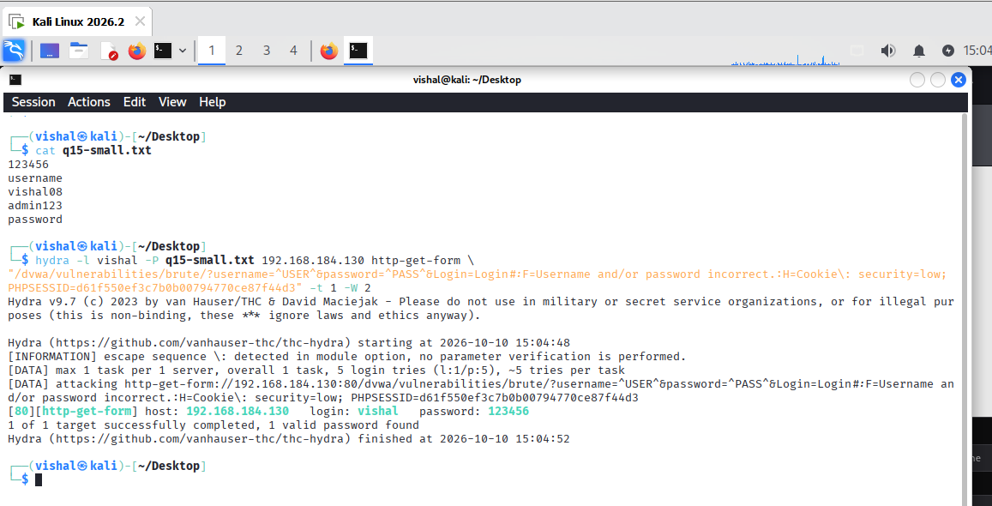
Observation
The DVWA Brute Force page displays a login form and an error message when incorrect credentials are submitted. Burp Suite can be used to inspect HTTP requests and responses sent between the browser and the application. Intruder can test a controlled set of input values and help compare the responses. However, the supplied Burp Suite screenshots show Command Execution requests, not a completed Intruder attack against the Brute Force page. Therefore, a successful Burp Suite Intruder attack cannot be confirmed from the current screenshots.
Security Measures
- Enforce strong password requirements.
- Limit repeated login attempts and apply temporary account lockouts where appropriate.
- Introduce rate limiting and delays between failed attempts.
- Enable multi-factor authentication.
- Monitor login failures and alert administrators to suspicious activity.

Conclusion
In this practical, I studied the DVWA Brute Force login page and learned how Burp Suite can be used to inspect HTTP requests and responses during login testing. I also reviewed how Intruder can be used for controlled input testing. The available screenshots do not show a completed Intruder attack against the Brute Force page, so a successful Burp Suite brute-force result cannot be claimed without additional evidence. The practical demonstrates why strong passwords, rate limiting, and monitoring are important for protecting web application login pages
Practical-7

AIM: “To use Google Search Operators (Google Dorking) to find specific publicly available information from search engine results”

Google Dorking is a search technique that uses advanced search operators to locate specific information indexed by search engines. Operators such as site:, inurl:, intitle:, address:, and cache: can narrow search results and help identify publicly available information. In ethical hacking, Google Dorking is used during the reconnaissance phase to understand information exposed by an authorized organization or laboratory environment.
We will perform the practical one operator at a time, using safe and authorized search targets. For each command, I’ll provide only the search query + short explanation first, and later we’ll select the important screenshots.
Operators we will cover
- site:
- inurl:
- intitle:
- address:
- cache:
cache: availability depends on the search engine and may not return results because cached-page features have changed over time.
Step 1 — site: Operator
Search Google for: site:jio.com
The site: operator restricts the search results to pages indexed under the specified domain. Here, site:jio.com displays publicly indexed pages belonging to Jio's website.

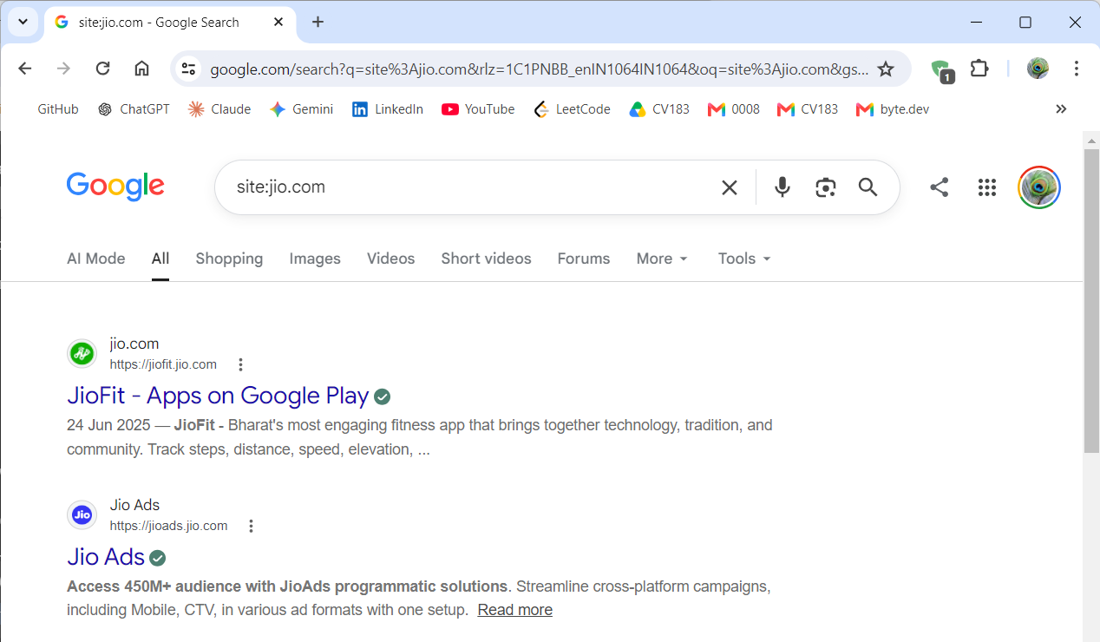
Screenshot 1: site: Operator Search Result
Explanation:
The screenshot shows a Google search using the site:jio.com operator. The results are restricted to pages and subdomains associated with the Jio domain, demonstrating how the site: operator can be used to limit search results to a specific website.

Step 2 — inurl: Operator
Search Google for: site:jio.com inurl:login
The inurl: operator searches for pages where the specified term appears in the URL. Here, inurl:login looks for Jio-domain pages whose URL contains the word login.

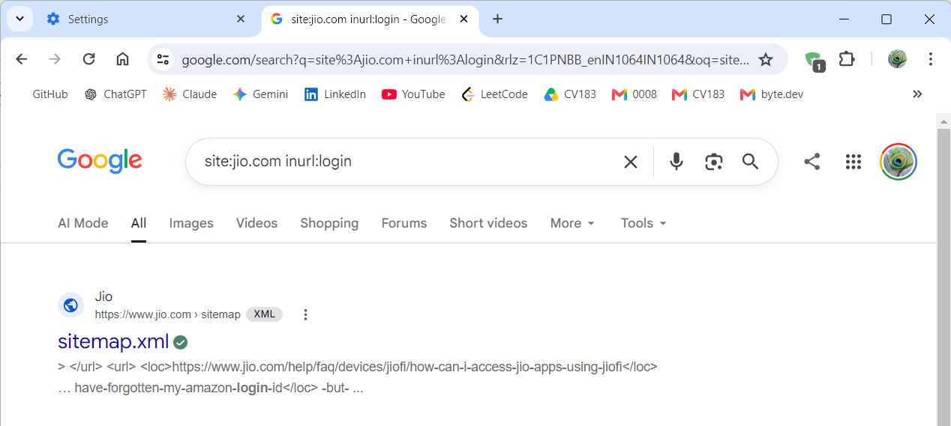
Screenshot 2: inurl: Operator Search Result
Screenshot Explanation:
The screenshot shows a Google search using site:jio.com inurl:login. The search is restricted to the Jio domain, while inurl:login searches for the term “login” in URLs indexed by Google. The result shown is sitemap.xml, where the search result snippet contains a URL containing login-id.

Step 3 — intitle: Operator
Search Google for:
site:jio.com intitle:login
The intitle: operator searches for pages where the specified word appears in the page title. Here, intitle:login looks for Jio pages with “login” in their title.
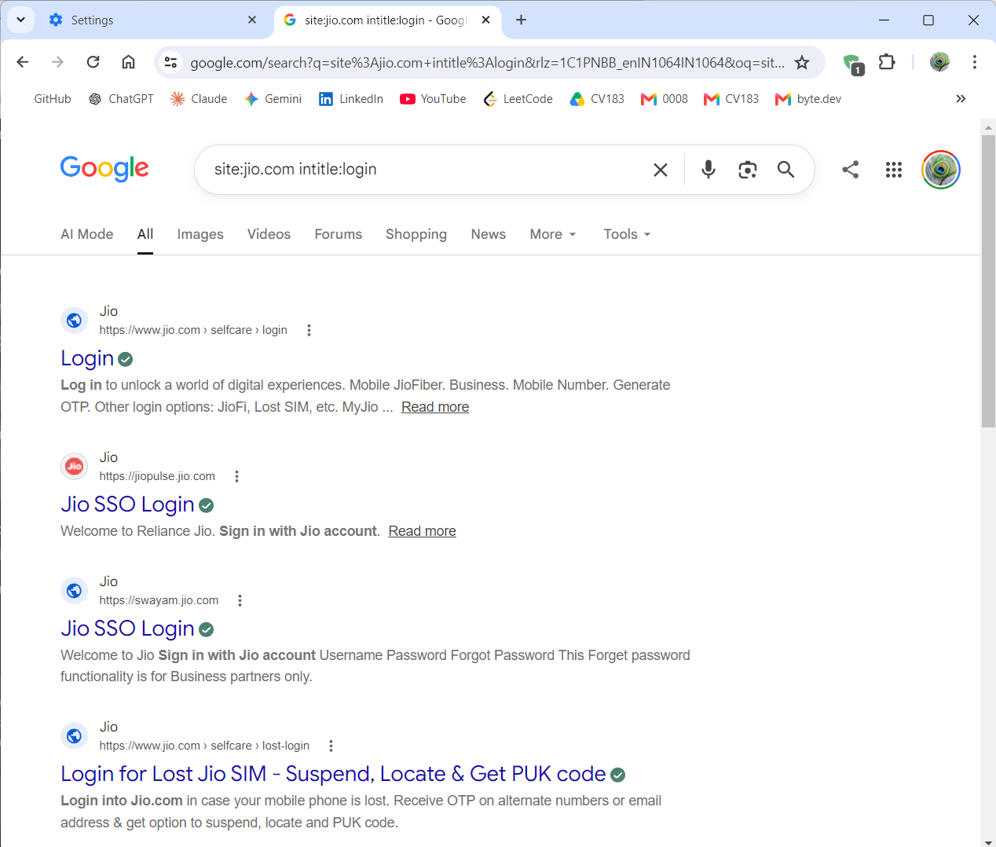
Screenshot 3: intitle: Operator Search Result
Screenshot Explanation:
The screenshot shows a Google search using site:jio.com intitle:login. The results are restricted to Jio-related domains, and the intitle:login operator returns pages with “Login” in their page title. Several login-related Jio pages are visible in the results.

Step 4 — address: Operator
Search Google for:
site:jio.com address:jio
The address: operator can be demonstrated as a search keyword for finding pages containing the specified address-related term. Here, address:jio is combined with site:jio.com to keep the search focused on Jio-related results.

Screenshot 4: address: Search
Screenshot Explanation:
The screenshot shows the Google search query site:jio.com address:jio. The results are restricted to Jio-related pages and include publicly indexed contact/location information, such as Jio customer-care details, store/service-center information, and a registered-office address.

Step 5 — cache: Operator
Use this query:
cache:jio.com
The cache: operator was historically used to access Google's cached copy of a webpage. However, Google no longer provides the traditional cached-page feature, so this query may return no useful cached result.
If Google shows no cached result, take a screenshot of the search result/no-result page as evidence that the traditional cache: feature is unavailable.

Conclusion:
The practical successfully demonstrated Google Dorking techniques using the site:, inurl:, intitle:, address:, and cache: operators. These operators helped narrow Google search results and identify publicly indexed information related to the Jio domain. The practical also demonstrated that the traditional Google cache: feature is no longer generally available.

Practical-8

AIM: “To perform network scanning and identify open ports and running services on a target system using Nmap.”

Nmap (Network Mapper) is a network scanning tool used to discover hosts, identify open ports, detect services, and gather information about network systems. It provides different scanning options for performing host discovery, port scanning, service/version detection, and operating system detection. In this practical, important Nmap options are demonstrated in an authorized lab environment using Kali Linux and Metasploitable 2.
Planned important Nmap options
We'll cover the useful options rather than literally every Nmap option:
- nmap <target> — basic scan
- -sS — TCP SYN scan
- -sT — TCP Connect scan
- -sU — UDP scan
- -p — specific port
- -p- — all TCP ports
- -F — fast scan
- -sV — service/version detection
- -O — OS detection
- -A — aggressive scan
- -Pn — skip host discovery
- -n — disable DNS resolution
- -T4 — faster timing
- -oN — save output to a normal text file

1. Basic Scan
nmap 192.168.184.129
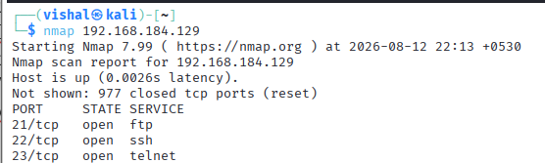
Explanation:
Performs a basic TCP port scan against the authorized Metasploitable 2 target and identifies commonly scanned open ports.

2. SYN Scan
nmap -sS 192.168.184.129
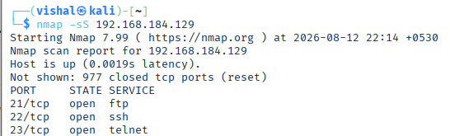
Explanation:
Performs a TCP SYN scan to identify open TCP ports. It sends SYN packets and analyzes the responses without completing the normal TCP connection.

3. TCP Connect Scan
nmap -sT 192.168.184.129
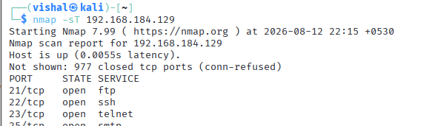
Explanation:
Performs a TCP Connect scan that completes the TCP connection with the target to determine whether ports are open.

4. Scan a Specific Port
nmap -p 21 192.168.184.129
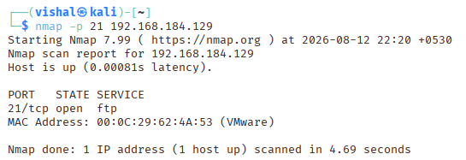
Explanation:
Scans only TCP port 21, commonly used by FTP, to determine whether the port is open on the target.

5. Scan Multiple Specific Ports
nmap -p 21,22,80,3306 192.168.184.129
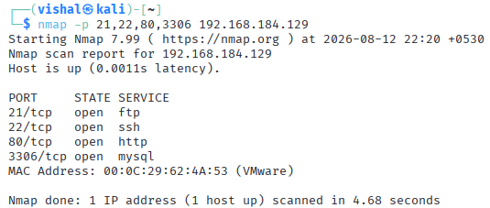
Explanation:
Scans the specified ports individually. This is useful for checking particular services such as FTP (21), SSH (22), HTTP (80), and MySQL (3306).

6. Scan All TCP Ports
nmap -p- 192.168.184.129
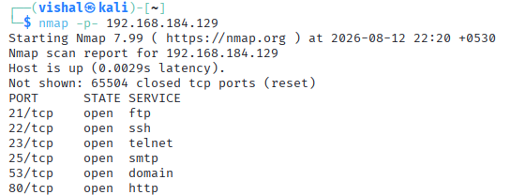
Explanation:
Scans all TCP ports from 1 to 65535 instead of only Nmap's default commonly scanned ports.

7. Service Version Detection
nmap -sV 192.168.184.129
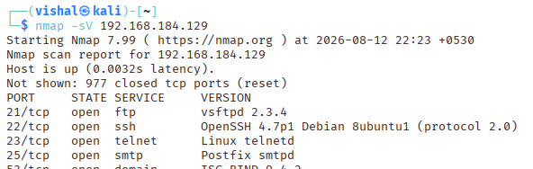
Explanation:
Detects the service name and version running on open ports, such as FTP, SSH, HTTP, or MySQL.

8. Operating System Detection
sudo nmap -O 192.168.184.129
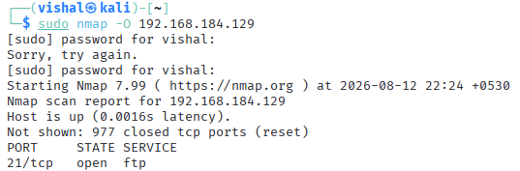
Explanation:
Attempts to identify the operating system and its version based on the target's network responses.

9. Service + OS Detection
sudo nmap -sV -O 192.168.184.129
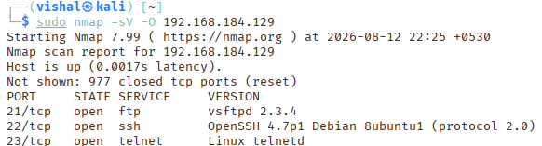
Explanation:
Combines service/version detection with operating-system detection to gather more detailed information about the authorized target.

10. Aggressive Scan
nmap -A 192.168.184.129
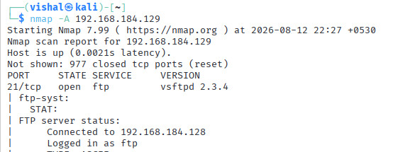
Explanation:
Performs an aggressive scan that combines several detection techniques, including OS detection, service/version detection, script scanning, and traceroute.

11. Skip Host Discovery
nmap -Pn 192.168.184.129
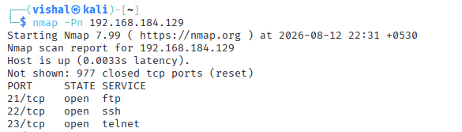
Explanation:
Skips the initial host-discovery phase and treats the target as online. This is useful when a target does not respond to normal host-discovery probes.

12. Disable DNS Resolution
nmap -n 192.168.184.129
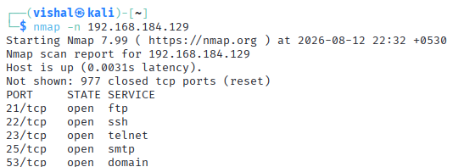
Explanation:
Disables DNS resolution during the scan, which can reduce unnecessary lookup time and display results without resolving hostnames.

Nmap — Command Group 5: Timing and Output
13. Faster Timing
nmap -T4 192.168.184.129
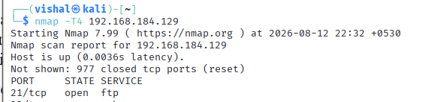
Explanation:
Uses Nmap's T4 timing template to perform the scan faster. Timing options control how aggressively Nmap sends probes.

14. Save Results to a Text File
nmap -sV 192.168.184.129 -oN nmap_result.txt
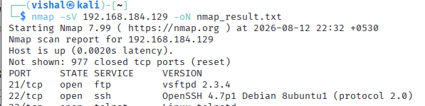
Explanation:
Performs service/version detection and saves the scan output in normal human-readable format to nmap_result.txt.

Conclusion:
The practical successfully demonstrated the use of Nmap for network reconnaissance and service enumeration in an authorized laboratory environment. Various Nmap options were used to perform basic port scanning, service and version detection, operating system identification, targeted port scanning, aggressive scanning, and output saving. The practical provided hands-on experience in gathering network information, which is an essential step in ethical hacking and penetration testing.

Practical-9
AIM: “Password Cracking Using Hashcat and John the Ripper.”

Step 1: Check the Tools and Prepare the Hash File.
- Check the installed Hashcat version using hashcat --version.
- Check whether John the Ripper supports MD5 using john --list=formats | grep -i md5.
- Create a file named hash.txt on the Desktop.
- Store the following MD5 hash in the file:
482c811da5d5b4bc6d497ffa98491e38
- Ensure that rockyou.txt and hash.txt are available in the Desktop directory.
- The hash corresponds to the sample password password123.
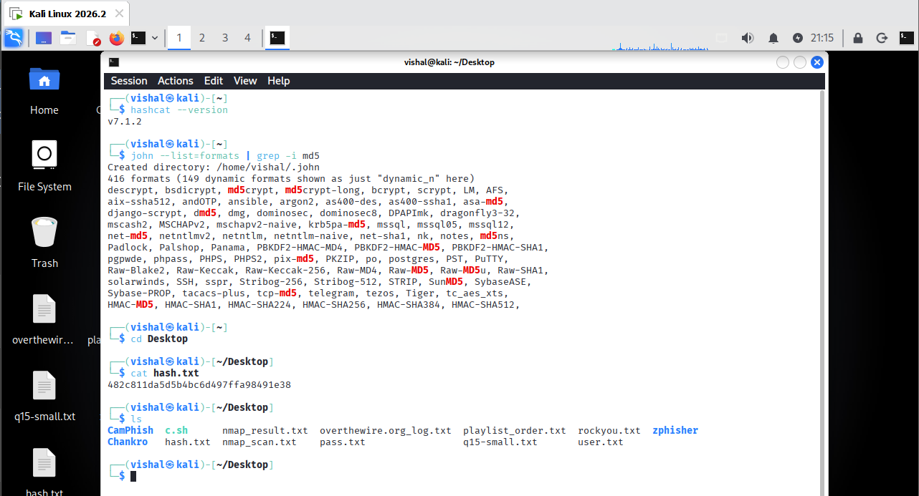
Figure 1: Check hachcat & joshtheripper version and hach file
Step 2: Crack the Hash Using Hashcat
- Run Hashcat with the MD5 mode and dictionary attack option:
hashcat -m 0 -a 0 hash.txt rockyou.txt
- Here, -m 0 specifies MD5 and -a 0 specifies a dictionary attack.
- Initially, Hashcat displayed an OpenCL error because no compatible runtime was available.
- Install the required CPU-based OpenCL runtime, PoCL, if needed.
- Run hashcat -I to check whether Hashcat detects an available device.
- Run the Hashcat command again after the runtime is available.
- Hashcat successfully matched the hash with password123.
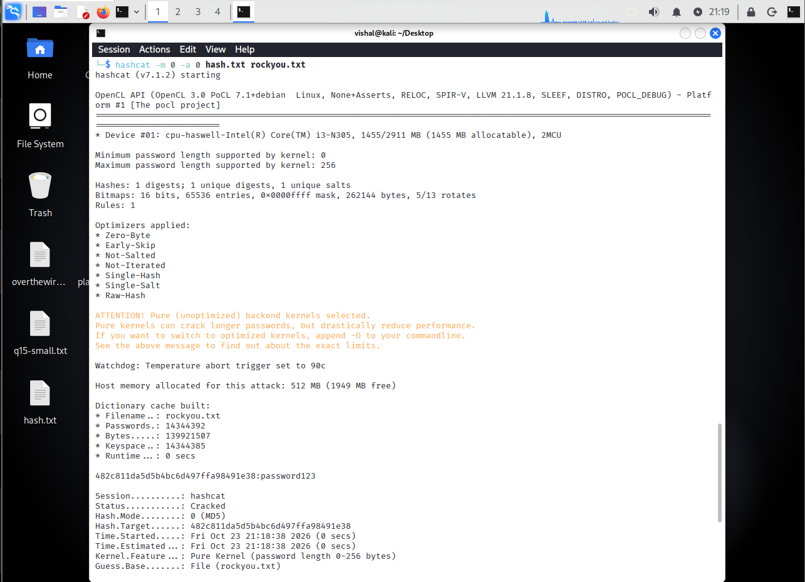
Figure 2: Hashcat Password-Cracking Result
POC Explanation: The screenshot shows that Hashcat detected the MD5 hash and processed the rockyou.txt wordlist. Its status is displayed as Cracked, and the result identifies password123 as the matching password.

Step 3: Crack the Hash Using John the Ripper
- Open the terminal and navigate to the Desktop directory.
- Execute the following command:
john --format=Raw-MD5 --wordlist=rockyou.txt hash.txt
- The --format=Raw-MD5 option specifies the hash format.
- The --wordlist option specifies the password list to use.
- John the Ripper loads the hash and checks the candidate passwords.
- The output shows that password123 matches the hash.
- The session completes after the password is recovered.
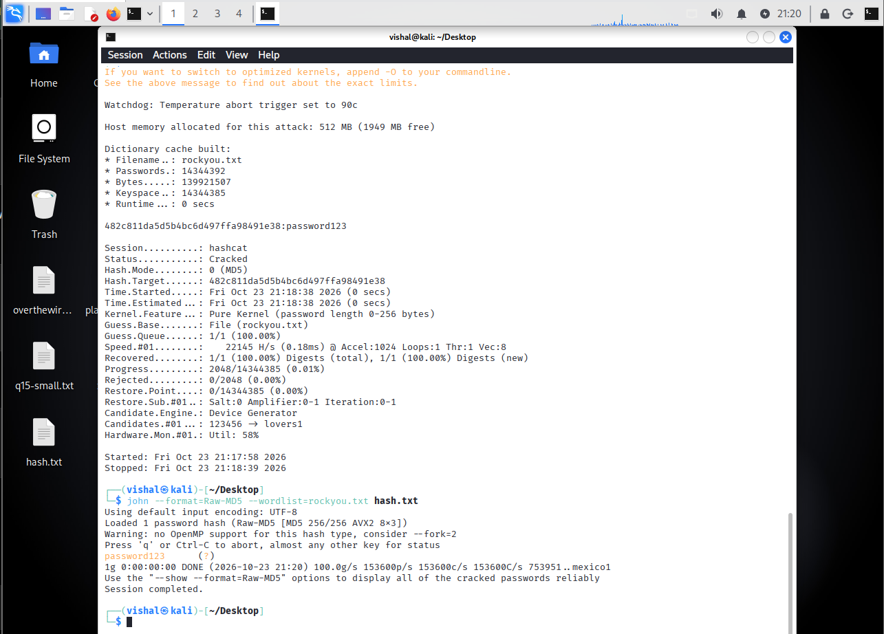
Figure 3: John the Ripper Password-Cracking Result
POC Explanation: The screenshot shows John the Ripper loading the Raw-MD5 hash and using the rockyou.txt wordlist. It displays password123 as the recovered password and indicates that the session is complete.
Observation
Hashcat and John the Ripper were used to test an MD5 hash with the rockyou.txt wordlist. Both tools successfully identified password123 as the matching password.
Conclusion
The practical demonstrated how dictionary-based password cracking works using Hashcat and John the Ripper. It also showed that weak passwords can be recovered when their matching values are present in a wordlist. MD5 is not recommended for password storage because it is fast to compute and unsuitable for secure password hashing.

Practical-10
AIM: “Cross-Site Scripting (Stored and Reflected XSS)”

Step 1: Configure DVWA Security
- Start Kali Linux and the virtual machine hosting DVWA.
- Open Firefox and access the DVWA web application.
- Log in using the lab credentials.
- Click on DVWA Security in the left-side menu.
- Select Low from the security-level dropdown.
- Click Submit to apply the setting.
- Confirm that the page displays the security level as low.
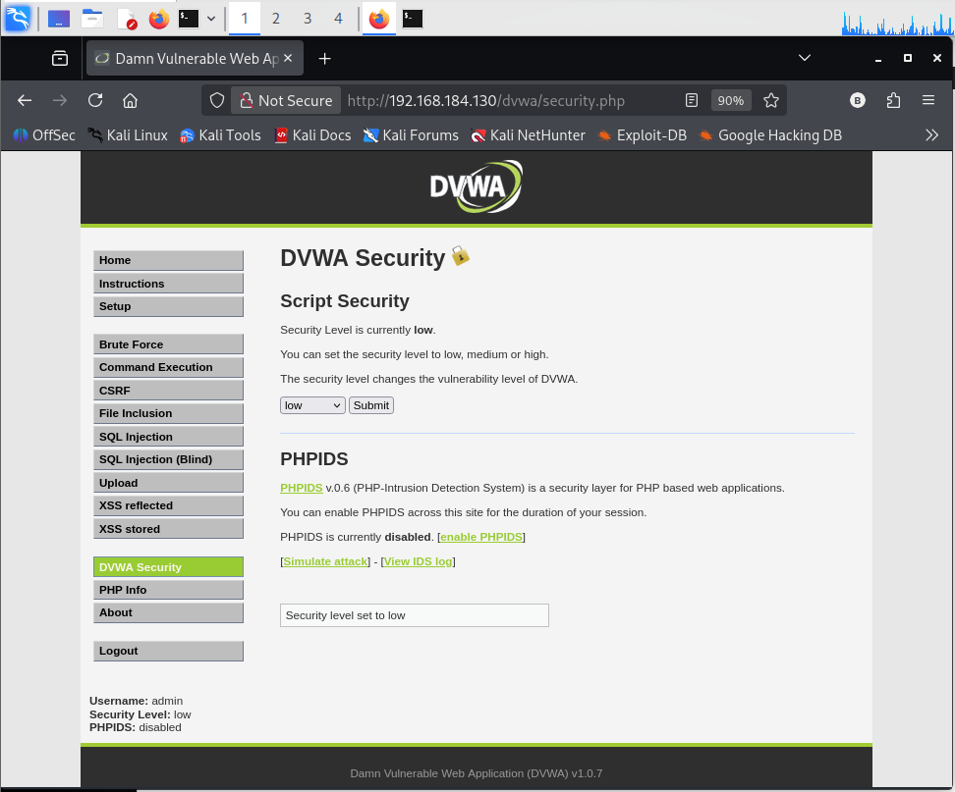
Figure 5: DVWA Security Configuration
POC Explanation: The screenshot shows the DVWA Security page with the security level set to Low. This configuration was used to demonstrate the XSS vulnerabilities in the controlled lab environment.
Step 2: Test Reflected XSS
- Click on XSS reflected in the left-side menu.
- Locate the input field provided on the page.
- Enter the following harmless JavaScript test payload:
<script>alert('Reflected XSS')</script>
- Submit the input using the page's button.
- Observe the browser response.
- In this practical, a JavaScript alert displaying Reflected XSS appeared.
- Capture a screenshot showing the alert.
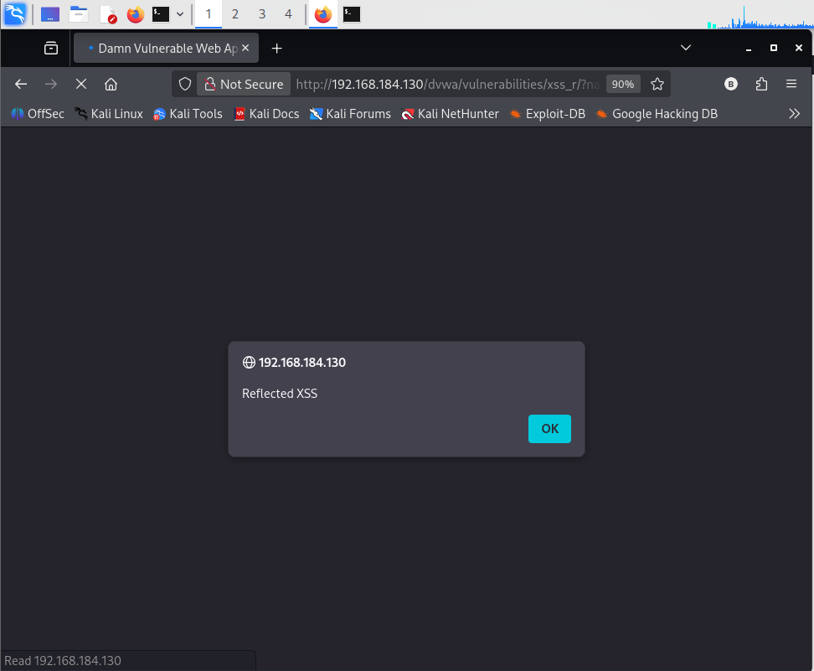
Figure 6: Reflected XSS Demonstration
POC Explanation: The screenshot shows a browser alert displaying “Reflected XSS.” This demonstrates that the submitted input was reflected in the response and interpreted as JavaScript by the browser.
Step 3: Test Stored XSS
- Click on XSS stored in the left-side menu.
- Locate the Name and Message fields in the guestbook form.
- Enter vishal in the Name field.
- Enter the following payload in the Message field:
<script>alert('Stored XSS')</script>
- Click Sign Guestbook to submit the message.
- Observe the browser response after submission.
- In this practical, a JavaScript alert displaying Stored XSS appeared.
- Capture a screenshot showing the submitted message and alert.
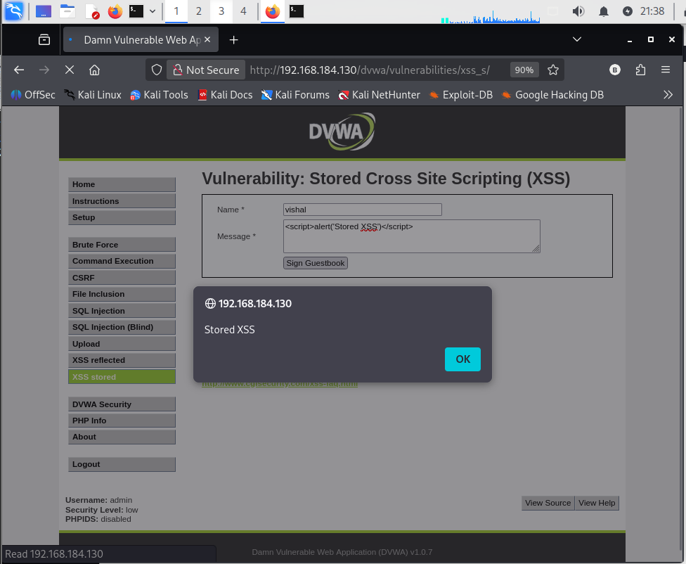
Figure 7: Stored XSS Payload and Alert
POC Explanation: The screenshot shows the payload entered in the guestbook form and an alert displaying “Stored XSS.” This demonstrates that the application processed the submitted content as executable JavaScript.
Step 4: Verify the Stored XSS Result
- Close the alert by clicking OK.
- Observe the guestbook page and the submitted entry.
- Reload the page to check whether the submitted content remains stored.
- Check whether the JavaScript alert appears again when the stored content is rendered.
- Record the observed result.
- Capture the final screenshot showing the stored entry or the alert, if available.
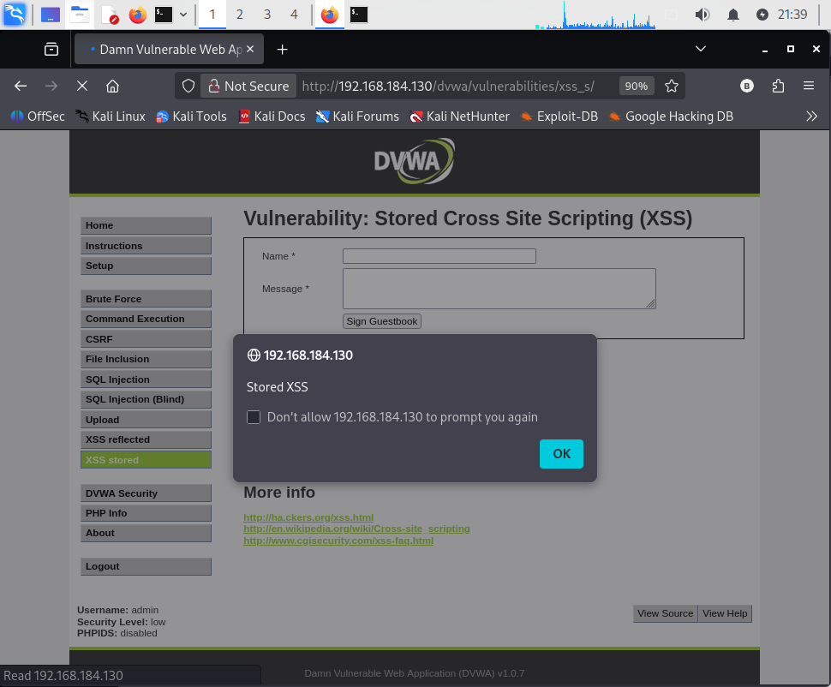
Figure 8: Stored XSS Result
POC Explanation: The screenshot shows the Stored XSS alert on the guestbook page. It provides evidence that the submitted content triggered JavaScript execution. A separate reload test is required to confirm that the stored payload executes again after refreshing the page.
Observation
Both Reflected XSS and Stored XSS were demonstrated using DVWA at the Low security level. The Reflected XSS test displayed an alert after input submission, while the Stored XSS test displayed an alert after submitting a guestbook message.
Conclusion
The practical demonstrated the difference between Reflected XSS and Stored XSS. Reflected XSS occurs when user input is returned in a response and executed by the browser, whereas Stored XSS occurs when submitted content is saved and later rendered as executable code. Proper output encoding, input validation, and Content Security Policy can help prevent these vulnerabilities.

Practical-11
AIM: “Passive Information Gathering Using nslookup and whois”

Procedure
Step 1: Collect Domain Registration Information Using WHOIS
- Open the terminal in Kali Linux.
- Execute the following command:
whois vulnweb.com
- Observe the domain name and registrar information displayed in the output.
- Identify the domain creation date, updated date, and registry expiry date.
- Observe the domain status and the name servers listed in the results.
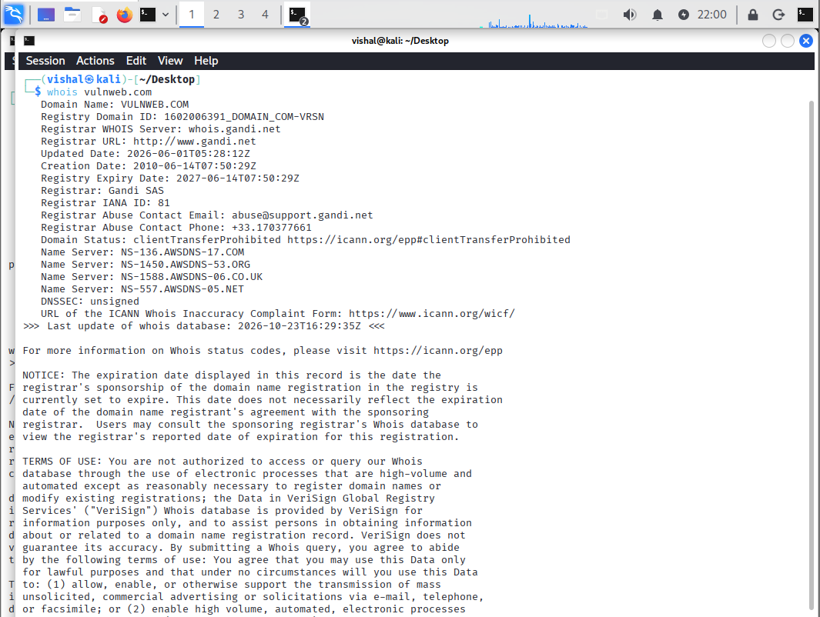
Figure 9: Domain Registration Information Using WHOIS
POC Explanation: The output displays registration information for vulnweb.com. The registrar is shown as Gandi SAS. It also displays the creation date, updated date, registry expiry date, domain status, and four name servers.

Step 2: Identify the Domain's IP Address Using nslookup
- Execute the following command:
nslookup vulnweb.com
- Observe the DNS server used to resolve the domain.
- Identify the IPv4 and IPv6 addresses returned in the output.

Step 3: Identify Mail Servers Using nslookup
- Execute the following command:
nslookup -type=MX vulnweb.com
- Observe the mail-exchange (MX) records returned by the DNS server.
- Record the mail-server hostnames displayed in the output.

Step 4: Identify Name Servers Using nslookup
- Execute the following command:
nslookup -type=NS vulnweb.com
- Observe the name servers returned by the DNS query.
- Record the name server hostnames displayed in the output.
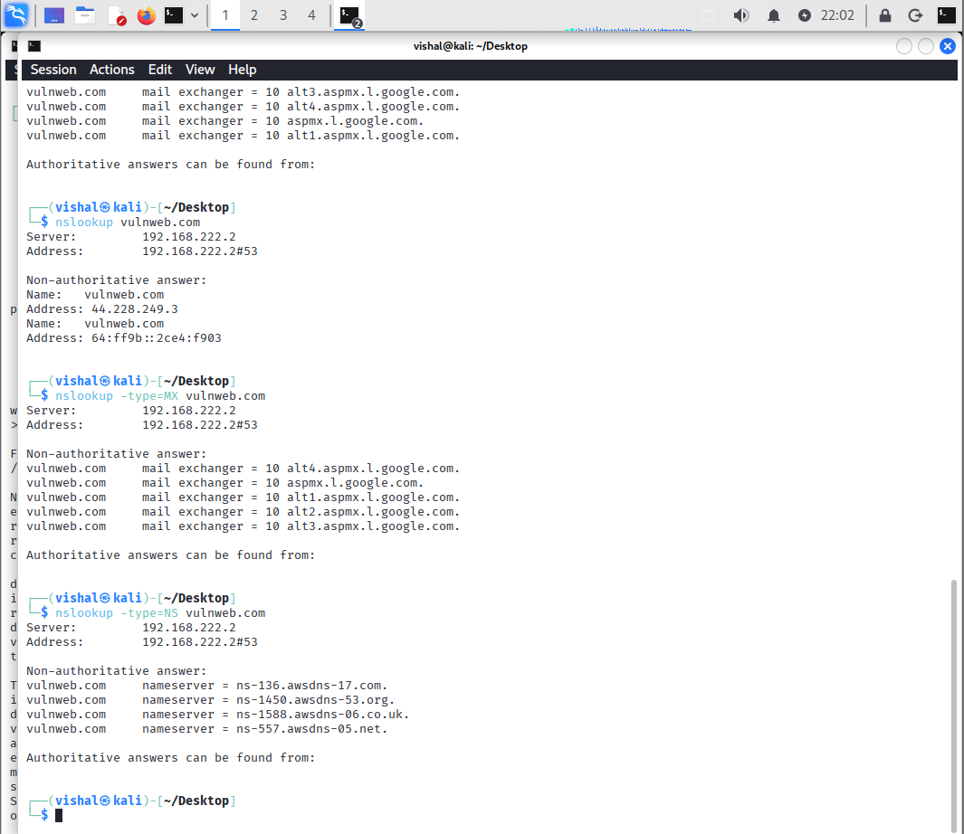
Figure 10: IP Address Information Using nslookup
POC Explanation:
The output displays the DNS server address and the IP addresses returned for vulnweb.com. The IPv4 address shown is 44.228.249.3, along with an IPv6 address.
The output lists Google mail-exchange servers associated with vulnweb.com, including several aspmx.l.google.com hostnames.
The output identifies four name servers associated with vulnweb.com: ns-136.awsdns-17.com, ns-1450.awsdns-53.org, ns-1588.awsdns-06.co.uk, and ns-557.awsdns-05.net. These entries are also visible in the WHOIS results.

Observation
The WHOIS command provided domain registration information, including the registrar, registration dates, domain status, and name servers. The nslookup commands returned the domain's IP addresses, mail-exchange records, and name server records.
Conclusion
The practical demonstrated passive information gathering using WHOIS and nslookup in Kali Linux. I learned how to collect publicly available domain registration and DNS information for the reconnaissance phase of a security assessment.

Practical-12
AIM: “DNS Zone Transfer Using nslookup & host”

Procedure
Step 1: Perform DNS lookup using nslookup
- Open the Kali Linux terminal.
- Execute the following command to look up the domain:
nslookup vulnweb.com
- Observe the DNS server address and the IP addresses returned for the domain.
- The output shows the IPv4 address 44.228.249.3 and an IPv6 address.
- This helps identify the IP addresses associated with the domain.

Step 2: Retrieve DNS records using nslookup
- Execute the following command to retrieve the mail exchange (MX) records:
nslookup -type=MX vulnweb.com
- Observe the mail servers returned in the output.
- Next, retrieve the domain's name server (NS) records:
nslookup -type=NS vulnweb.com
- The output lists the name servers responsible for the domain's DNS service.
- These records help identify the mail service and DNS infrastructure.
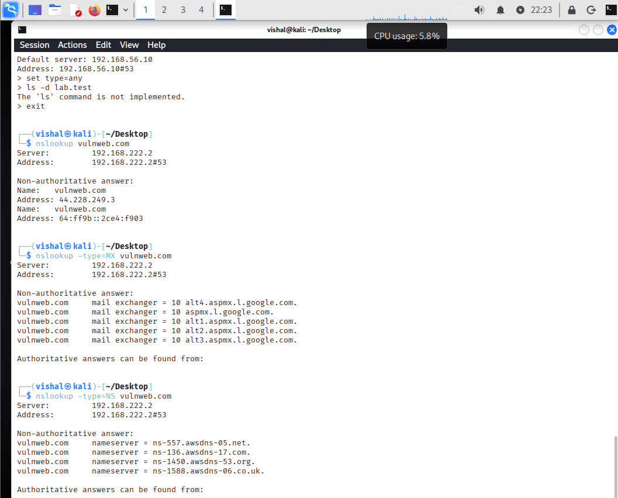
Figure 11: Output of nslookup showing the domain's IP, MX and NS records.
POC Explanation
In this POC, I used the nslookup command to gather DNS information about vulnweb.com. The output displayed the domain's IPv4 and IPv6 addresses. I then queried the MX records to identify the mail servers and the NS records to identify the domain's name servers. This practical helped me understand how nslookup retrieves DNS information from a DNS server.
Step 3: Gather DNS records using host
- Execute the following command to retrieve the domain's DNS information:
host vulnweb.com
- Observe the IPv4 and IPv6 addresses and the mail servers displayed.
- Retrieve the name server records using:
host -t NS vulnweb.com
- Retrieve the mail exchange records using:
host -t MX vulnweb.com
- Compare these results with the information obtained through nslookup.

Step 4: Check DNS zone transfer availability
- A DNS zone transfer can reveal DNS records when a DNS server improperly allows an unauthorized transfer.
- In the lab screenshot, the command below was attempted:
host -t lab.test 192.168.56.10
- The output shows a connection timeout, indicating that the DNS server did not respond to this request.
- An interactive nslookup session was also opened, and the DNS server was set to 192.168.56.10.
- The command ls -d lab.test returned the message that the command is not implemented.
- Therefore, the screenshots do not demonstrate a successful zone transfer. They show DNS record enumeration and an unsuccessful attempt to query the specified lab server.
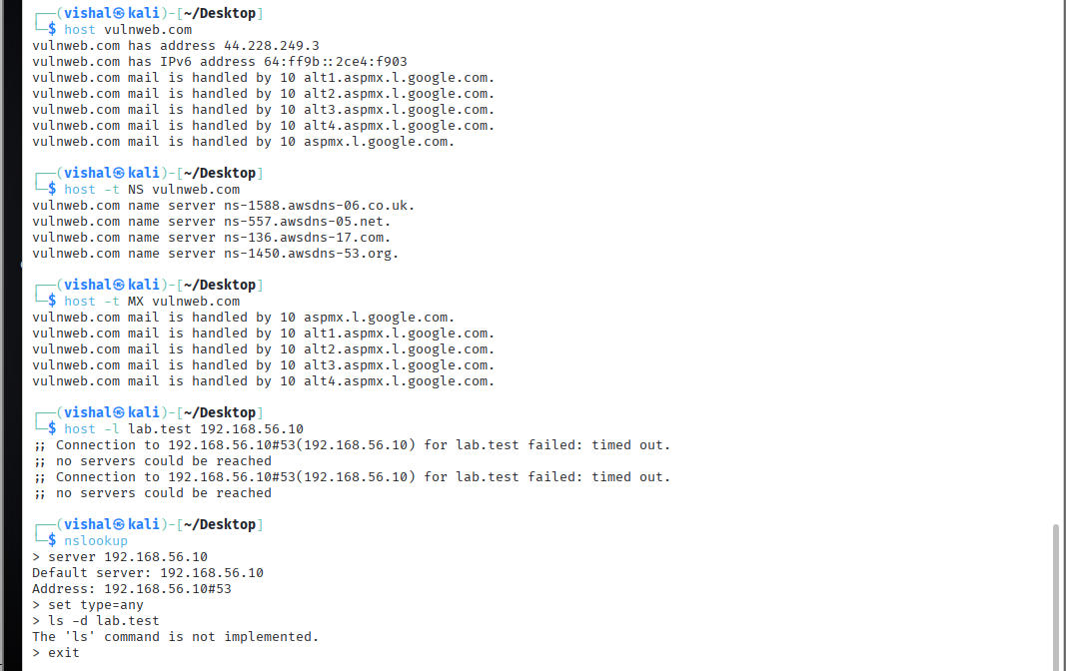
Figure 12: Output of host commands and the unsuccessful DNS query to 192.168.56.10.
POC Explanation
In this POC, I used the host command to retrieve the IP addresses, name servers, and mail exchange records of vulnweb.com. I also attempted to query the lab DNS server at 192.168.56.10, but the request timed out. In the interactive nslookup session, the ls -d lab.test command returned a message stating that the command was not implemented. Therefore, the output demonstrates DNS enumeration and an unsuccessful query, but it does not confirm a successful DNS zone transfer.

Observation
The nslookup and host commands retrieved DNS information for vulnweb.com, including its IP addresses, mail servers and name servers. The attempt to query 192.168.56.10 timed out, and the interactive nslookup session did not support the ls -d command. No successful DNS zone transfer was observed.

Conclusion
In this practical, I learned how to use nslookup and host to gather DNS information, including IP addresses, mail servers, and name servers. I also attempted to query a DNS server to check zone transfer availability. However, the request timed out, and a successful zone transfer could not be confirmed. This practical helped me understand the importance of properly configuring DNS servers to prevent unauthorized zone transfers.

Practical-13

AIM: “SQL Injection on DVWA – UNION Attack”

Procedure
Step 1: Configure DVWA Security
- Start the Kali Linux virtual machine and open Firefox.
- Open the DVWA application using the lab URL.
- Log in to DVWA using the available lab credentials.
- Click on DVWA Security from the left-side menu.
- Select Low from the security-level dropdown menu.
- Click Submit to apply the security setting.
- Confirm that the displayed security level is Low.
Figure 13: DVWA Security page showing the security level set to Low.
POC Explanation
In this step, I opened the DVWA Security page and selected the Low security level. This setting was used to perform the SQL Injection practical in the intentionally vulnerable lab environment.
Step 2: Test the Normal SQL Injection Input
- Click on SQL Injection from the left-side menu.
- Observe the User ID input field on the page.
- Enter the value 1 into the input field.
- Click the Submit button.
- Observe the result displayed by DVWA.
- The application displays the user information associated with ID 1.
- In my test, the returned record showed the first name as admin and the surname as admin.
- This response was used as the baseline for comparison with the UNION attack.
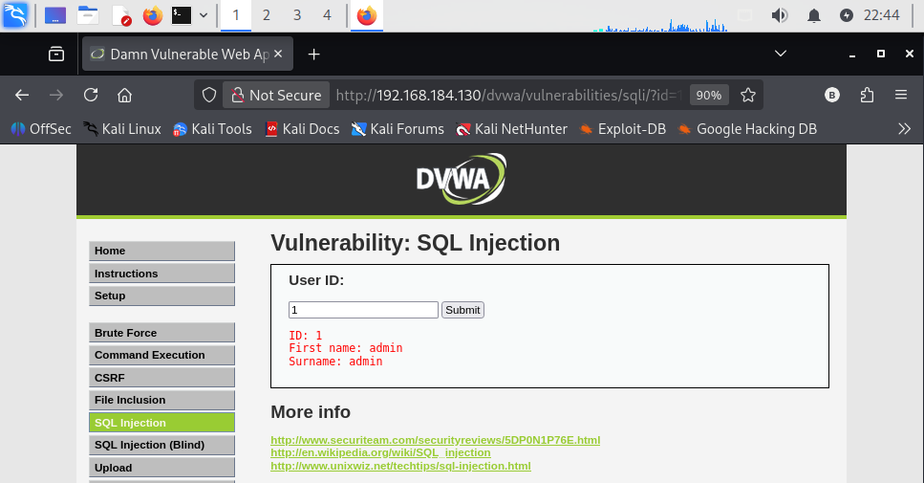
Figure 14: DVWA SQL Injection page displaying the result for User ID 1.
POC Explanation
In this step, I entered the value 1 in the User ID field and submitted it. DVWA displayed the record with the first name admin and surname admin. This confirmed that the application retrieved database information based on the supplied input.

Step 3: Perform the UNION Attack
- Keep the DVWA SQL Injection page open with the security level set to Low.
- Enter the following test value in the User ID field:
1' UNION SELECT 1, column_name FROM information_schema.columns WHERE table_name='users'-- -
- Click Submit to execute the test.
- Observe the information displayed in the response.
- The output shows column names associated with the users table.
- The visible results include user_id, first_name, last_name, user, password, and avatar.
- The results demonstrate that the injected query was able to retrieve database schema information.
- This indicates that the application is vulnerable to SQL Injection at the tested security level.
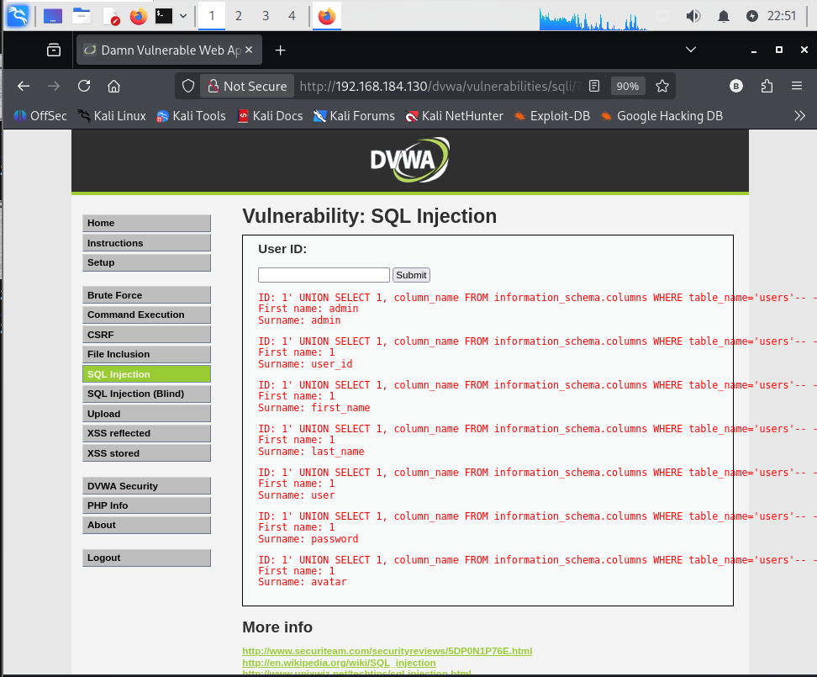
Figure 15: DVWA SQL Injection page displaying database column names obtained through the UNION query.
POC Explanation
In this step, I entered a UNION-based SQL Injection test value in the User ID field. The output displayed column names from the users table, including user_id, first_name, last_name, user, password, and avatar. This demonstrates that the vulnerable application processed the injected SQL query and exposed database schema information.

Observation
The normal input returned the user record associated with ID 1. When I performed the UNION attack, the application displayed column names from the users table. This showed that the SQL query could be manipulated through user input when the security level was set to Low.
Security Measures
- Use parameterized queries or prepared statements.
- Validate user input before processing it.
- Avoid constructing SQL queries by directly concatenating user input.
- Use database accounts with only the permissions required by the application.
- Apply appropriate error handling to avoid exposing database details.

Conclusion
In this practical, I learned how to perform a SQL Injection UNION attack on DVWA. I first tested a normal User ID and then used a UNION query to retrieve database column names. The results demonstrated how improper handling of user input can expose database information. Parameterized queries and proper input validation can help prevent SQL Injection vulnerabilities.

Practical-14
AIM: “Gain Reverse Shell via File Upload Vulnerability (revshells.com & Weevely)”

Step 1: Configure the Reverse-Shell Payload
Open revshells.com and configure the payload with the following settings:
- IP Address: 192.168.222.128
- Port: 4444
- Operating System: Linux
- Payload: PHP PentestMonkey
- Encoding: None
Generate the PHP payload, copy the raw code, and save it on the Kali Linux Desktop as reverseshell_dvwa.php.
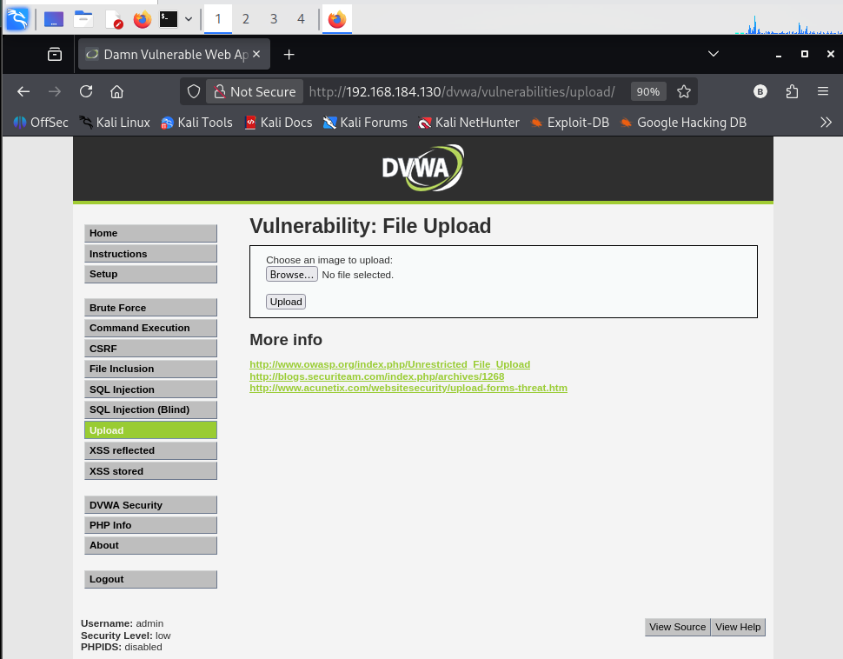
Figure 16: Configuration of PHP PentestMonkey Reverse-Shell Payload on revshells.com.
PoC Explanation:
This screenshot shows the reverse-shell payload configuration, including the IP address, port, operating system, and PHP payload type. These settings identify the intended callback destination for the lab demonstration.

Step 2: Start the Listener on Kali Linux
Open a terminal in Kali Linux and execute the following command: nc -lvnp 4444
Keep the terminal open while performing the authorized lab test. The listener waits for an incoming connection on port 4444.
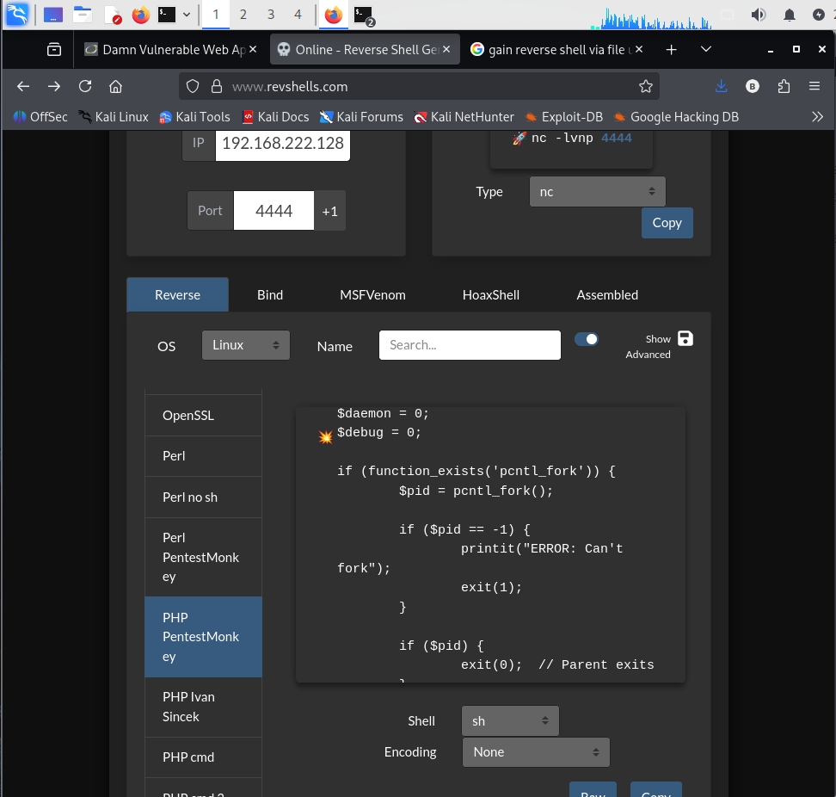
Figure 17: Netcat Listener Started on Kali Linux for Reverse-Shell Connection Monitoring.
PoC Explanation: This screenshot establishes that Netcat is listening on port 4444 on the Kali machine. The listener is used to observe an incoming connection from the vulnerable target.

Step 3: Upload the PHP File Through DVWA
Open DVWA in the browser and navigate to: Vulnerabilities → Upload
The lab is configured at Low security. Select reverseshell_dvwa.php from the Kali Desktop and submit it using the Upload button.
The application displays the following confirmation:
../../hackable/uploads/reverseshell_dvwa.php successfully uploaded!
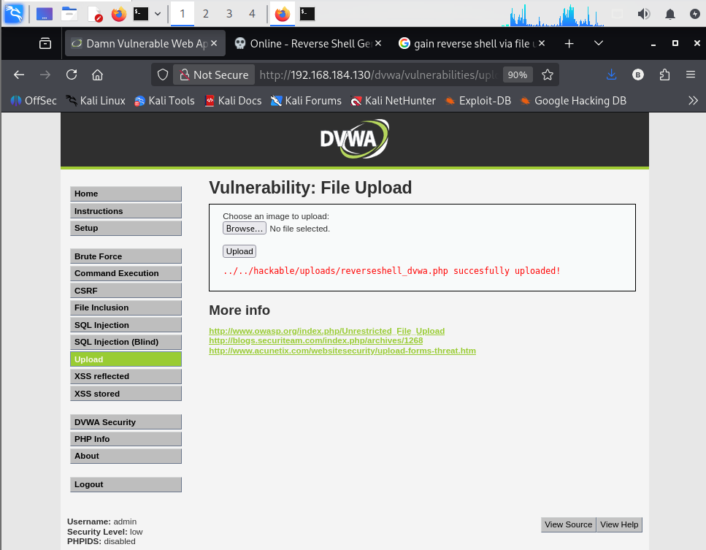
Figure 18: Successful Upload of the PHP Reverse-Shell File Through the DVWA File Upload Vulnerability.
PoC Explanation: The screenshot confirms that DVWA accepted the PHP file and stored it in the upload directory. This demonstrates insufficient file-type validation in the configured low-security environment. Successful upload alone does not establish that the PHP code executed.

Step 4: Observe and Verify the Result
Observe the Kali terminal running Netcat and document the connection information and command output produced during the lab test.
The output indicates that a connection was received from the Metasploitable host at 192.168.1.3. The shell process was running as www-data, the web-server account, rather than as root.
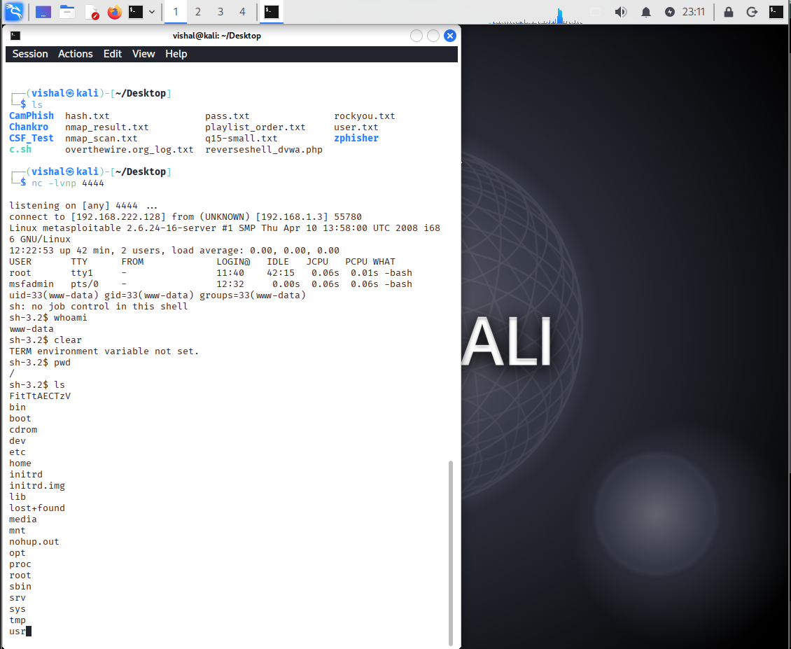
Figure 19: Successful Reverse-Shell Connection from Metasploitable 2 to Kali Linux.
PoC Explanation: The terminal output demonstrates a successful callback to the Netcat listener, identifies the target operating system, and shows the effective shell identity as www-data. The whoami and pwd outputs provide evidence of command execution in the remote shell.

Observations
The PHP PentestMonkey payload was configured with the Kali IP address and listening port. Netcat was started on Kali Linux to receive the incoming connection. DVWA accepted the PHP file and displayed a successful upload message. The listener received a connection from the Metasploitable 2 system. The remote shell executed commands with the privileges of the www-data account. The clear command displayed a TERM environment variable not set message, indicating that the shell lacked a properly configured terminal environment. This did not prevent the other demonstrated commands from running.

Conclusion
The practical demonstrated how insufficient file-upload validation in a deliberately vulnerable web application can create a security risk when uploaded PHP files are executable by the web server. The captured evidence shows a successful connection from Metasploitable 2 to Kali Linux and command execution under the restricted www-data account. This highlights the importance of strict server-side file validation, storing uploads outside executable directories, and disabling script execution in upload locations.

Practical-15
AIM: “Privilege Escalation on Metasploitable 2”

Procedure
Step 1: Establish Initial Access and Enumerate User Privileges

From Kali Linux, verify that the Metasploitable 2 target is reachable and connect to the Metasploitable 2 target (192.168.184.130) through SSH using the low-privileged account user.
ping -c 4 192.168.184.130
ssh -o HostKeyAlgorithms=+ssh-rsa user@192.168.184.130
After successful login, the following commands were executed to identify the current user, permissions, system information, and potential privilege-escalation weaknesses.
whoami
id
hostname
uname -a
sudo -l
find / -type f -perm -4000 2>/dev/null
The output confirmed that the current user was user with UID 1001, and the account was not permitted to execute commands through sudo. The SUID enumeration identified /usr/bin/nmap as a potential privilege-escalation path.
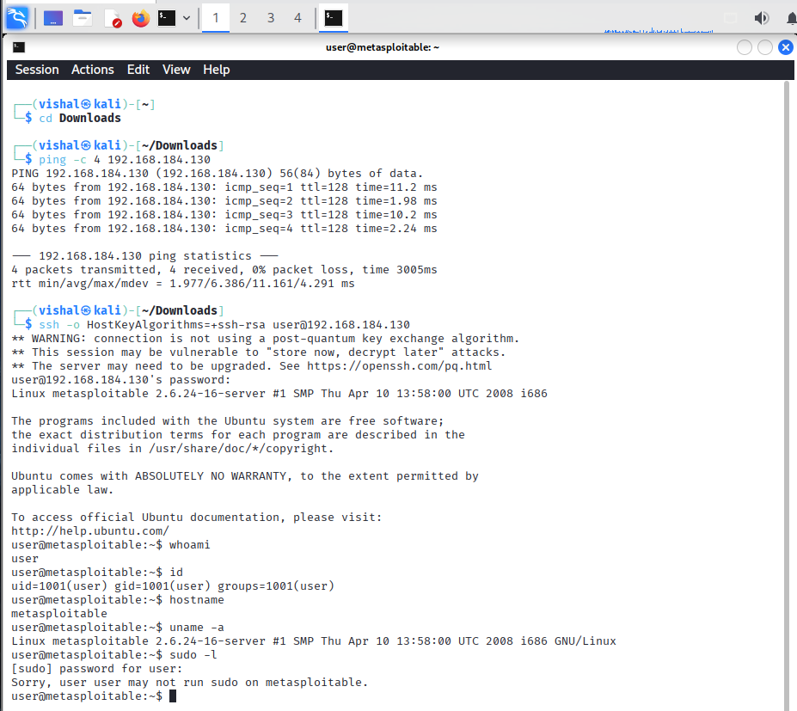
Figure 20: Initial SSH Access and Enumeration of Privileges on Metasploitable 2.
PoC Explanation:
The screenshot shows successful SSH access using the low-privileged account, the account's identity and permissions, the sudo restriction, and the list of SUID-enabled executables.

Step 2: Exploit the SUID-Enabled Nmap Vulnerability
The Nmap executable was examined to verify its ownership, SUID permissions, and version.
ls -l /usr/bin/nmap
/usr/bin/nmap --version
The output confirmed that /usr/bin/nmap was owned by root, had the SUID bit enabled, and was running Nmap version 4.53. The legacy interactive functionality was then used in the lab to demonstrate privilege escalation.
The final commands verified the resulting identity:
whoami
uname -a
id
The captured output showed root from whoami and euid=0(root) from id, while the real UID remained 1001(user).
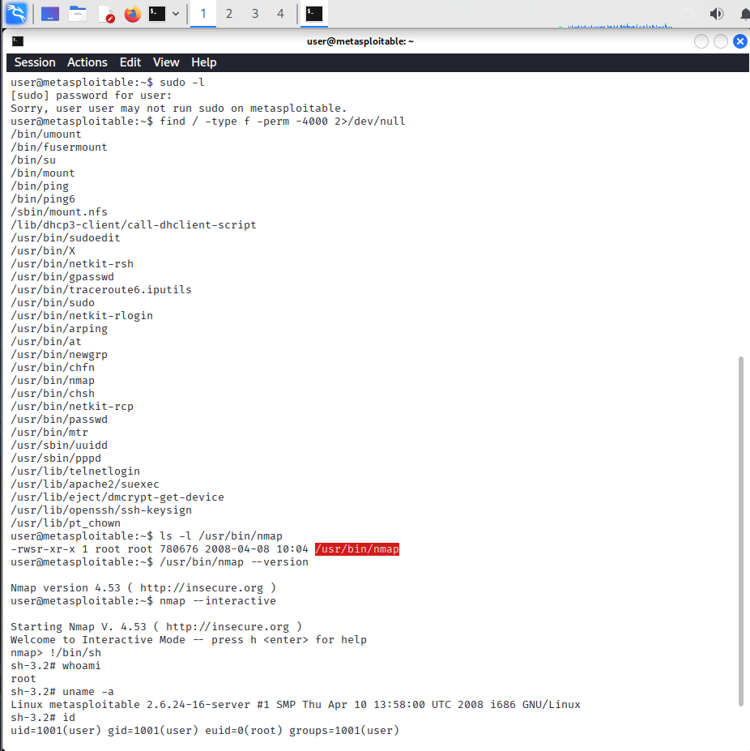
Figure 21: Successful Privilege Escalation Through SUID-Enabled Nmap 4.53.
PoC Explanation:
The screenshot demonstrates the root-owned SUID executable and the resulting elevated shell. The whoami and id outputs confirm that the process obtained root-level effective privileges through the legacy Nmap configuration.

Observations
- SSH access was established to Metasploitable 2 using the low-privileged user account.
- The initial account had UID 1001 and could not run commands through sudo.
- Enumeration identified /usr/bin/nmap as a root-owned executable with SUID enabled.
- The installed Nmap version was 4.53, which supports legacy interactive mode.
- The interactive-mode test provided a shell with root-level effective privileges.
- The final identity check showed euid=0(root) while retaining the original real UID of 1001(user).

Conclusion
The privilege-escalation practical was successfully demonstrated on the intentionally vulnerable Metasploitable 2 system. Starting from a low-privileged SSH session, SUID enumeration identified an insecure legacy Nmap configuration. The final evidence showed root-level effective privileges, demonstrating how incorrectly configured SUID executables can allow privilege escalation. The finding highlights the importance of removing unnecessary SUID permissions, replacing obsolete software, and following the principle of least privilege.

